Cite this: DOI: 10.1039/x0xx00000x
Received 00th January 2012,
Accepted 00th January 2012
DOI: 10.1039/x0xx00000x
www.rsc.org/
Bioconversion of oxygen-pretreated Kraft lignin to microbial lipid with oleaginous Rhodococcus opacus DSM 1069
Zhen Wei^{a,b}, Guangming Zeng^{a,b*}, Fang Huang^{c}, Matyas Kosa^{c}, Danlian Huang^{a,b}, Arthur J. Ragauskas^{c,d*}

Kraft lignin (KL) from black liquor is an abundantly available, inexpensive aromatic resource that is regarded as a low value compound by the pulp and paper industry, necessitating the development of new applications. Current work proposes an innovative KL utilization strategy that connects partial lignin degradation with lipid production in oleaginous Rhodococcus. Results showed poor bacterial growth when KL was used directly as a substrate. On the other hand, when KL recalcitrance was reduced by oxygen-pretreatment (O₂-KL), Rhodococcus opacus DSM 1069 was capable of utilizing this material and in turn accumulated lipids. The maximum lipid yield was measured to be 0.067 mg/ml at 36 h of growth and these lipids were mainly composed of palmitic (46.9%) and stearic (42.7%) acids.

Lignocellulosic biomass represents a renewable and carbon-neutral resource for the production of bio-fuels and bio-chemicals. On average lignocellulosic biomass contains around 35-50% of cellulose, 25-30% of hemicellulose and another 15-30% of lignin. Lignin is a random three-dimensional polyphenolic biopolymer derived from coniferyl, coumaryl, and sinapyl alcohols¹. Compared with plant polysaccharides, lignin is generally regarded as a more complex and recalcitrant compound and has received much less attention as a resource for biofuel production. For example, the pulp and paper industry generates over 50 million tons of residual lignin as byproduct each year; and only 1-2% of lignin is sold commercially^{2,3}. Typically, Kraft lignin (KL), which is produced at the scale of over 6.3×10⁸ kg annually, has been mostly used as an inexpensive energy source in recovery boilers to this date ⁴.
Bacterial species with lipid-accumulating capability have been researched by multiple groups to establish new means of biomass component conversion⁵⁻⁷. These microorganisms can accumulate over 20% of their own weight in lipids, a trait also known as oleaginicity⁸. During bacterial conversion, the metabolic route connecting aromatic catabolism with lipid anabolism represents fundamentally new lignin utilization strategy. The core of this metabolic route has already been proven possible by using Rhodococcus opacus (R. opacus) bacteria to degrade lignin model compounds and convert them into triacylglycerols (TAG) that were accumulated at oleaginous levels⁹. Subsequent research has probed technical lignin-to-lipid bioconversion and ethanol organosolv lignin (EOL) from extracted loblolly pine was demonstrated to be a possible feed source for bacterial growth; however, lipid accumulation was limited¹⁰. Considering that the economic viability of microbial biomass production processes are limited by the cost of the fermentation medium¹¹, Kraft lignin could represent a feasible and green carbon source for the digesting bacterial cells that in turn could accumulate lipids as biodiesel feed-stocks.
Initial efforts toward the fermentation of KL by R.opacus however gave poor results¹², which may be due to KL’s relatively higher molecular weight, as compared to EOL. Consequently, improving KL properties, e.g. lowering molecular weight, appears to be crucial for microbial applications with better efficiency. In addition, as an important starting point for lignin valorization strategies,

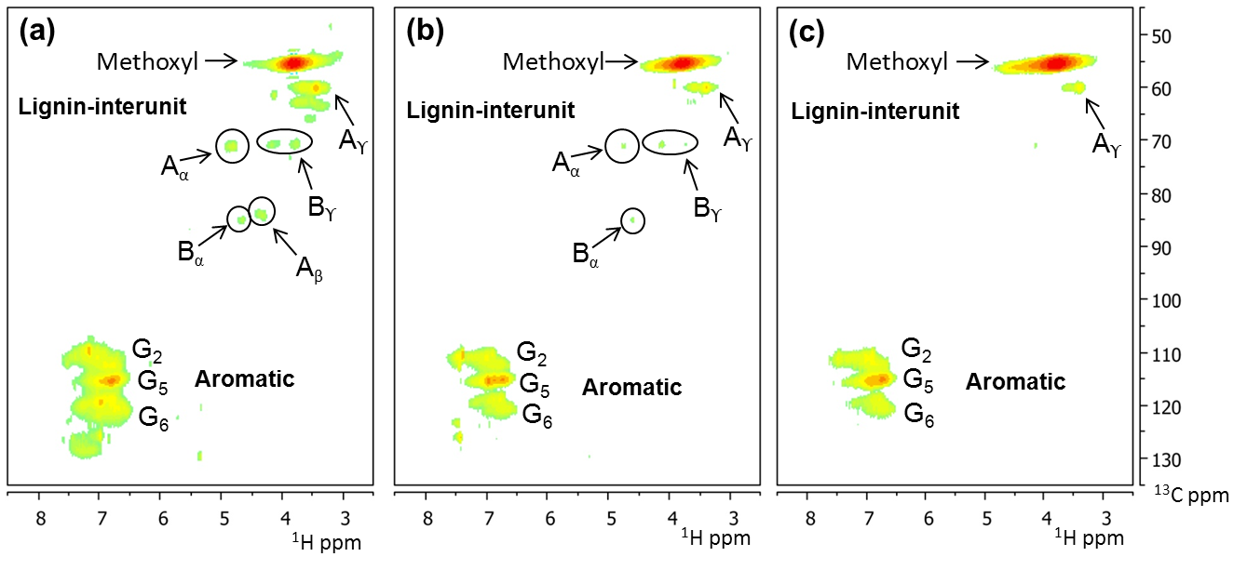
Fig. 1. Aromatic and lignin interunit regions in the HSQC-NMR spectra from various Kraft lignins, (a) the staring Kraft lignin, (b) O₂-pretreated Kraft lignin, (c) O₂-pretreated Kraft lignin after 7-day fermentation. The structures of G, A, B can be found in Fig. 2

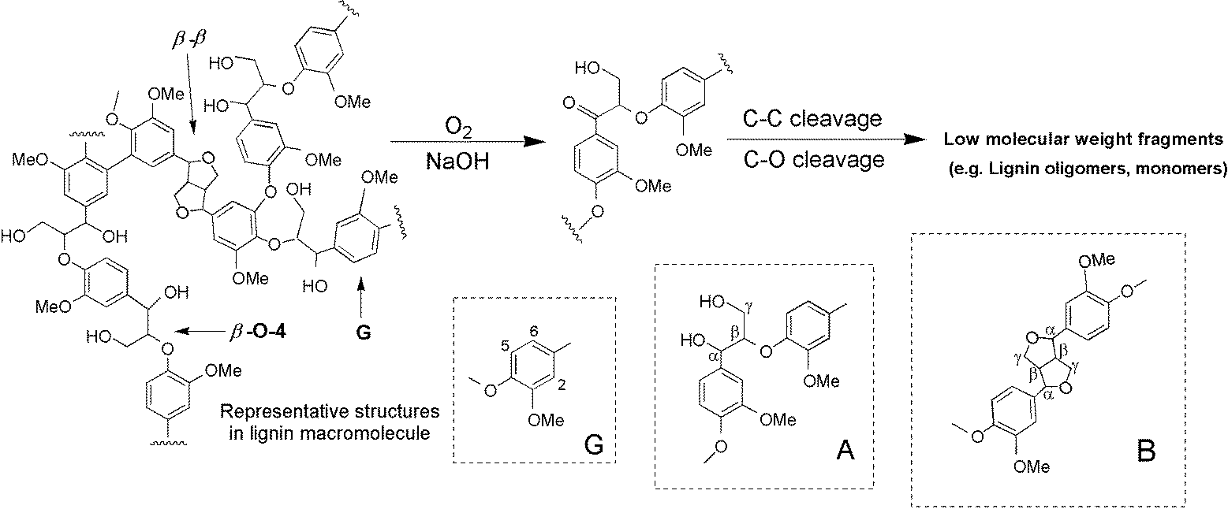
Fig. 2. Potential Kraft lignin depolymerization mechanism during O₂ pretreatment. The lignin substructures identified are; A, β-O-4′ substructures; B, resinol substructures formed by β−β′/α-O-γ′/γ-O-α′ linkages; G, guaiacyl units. ^{14-16,21-23}

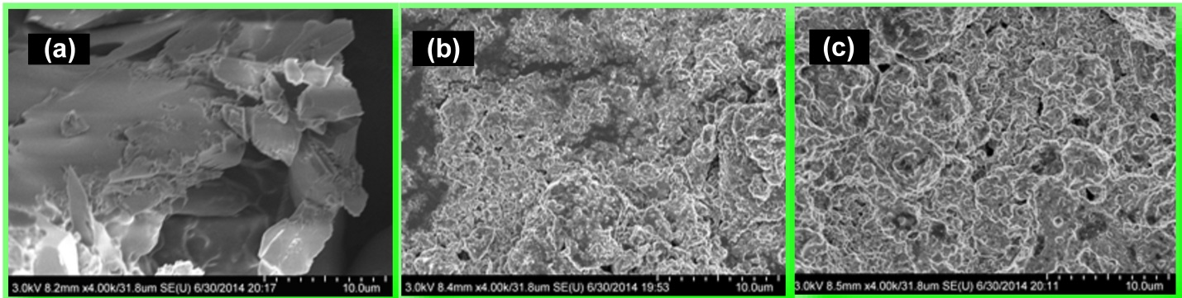

Fig. 3. SEM images of Kraft lignin: (a) the starting Kraft lignin; (b) O₂-pretreated Kraft lignin;
(c) O₂-pretreated Kraft lignin after 7-day fermentation.

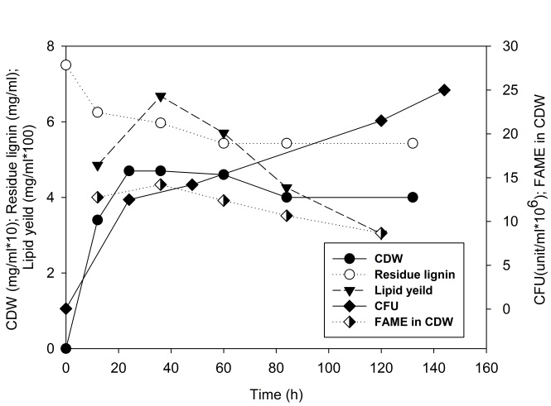
Fig. 4. Fermentation of R. opacus DSM 1069 using O₂-KL as the only carbon source. CDW (mg/ml) and lipid yield (mg/ml) multiplied by 10 and 100 respectively to enable illustration on the same chart.

depolymerization can generate diverse, valuable aromatic chemicals and low-molecular-weight feed-stocks which can be suitable for further processing¹³. Oxygen-delignification (O₂-delignification), as an environmentally benign technology, has been applied for decades in the production of bleached pulps. This process uses oxygen and alkali to remove the residual lignin from cellulose fibers at elevated temperatures¹⁴. The work of Gierer and colleagues concluded that this process is mainly attributed to the reaction of oxygen with the phenolic structures in lignin, resulting in the formation of phenoxy radicals and other oxy-radicals which can induce the fragmentation of the aromatic rings in lignin, while also causing side-chain scissions¹⁵. The degradation of non-phenolic structures has also been reported involving in the oxygen-process^{15,16}. Further information provided by Gellerstedt, et al.¹⁷, Moe and Ragauskas¹⁸, and Argyropoulos¹⁹ indicated that there are significant changes in the residual lignin structure appearing after the O₂-delignification process. These changes indicate the loss of non-condensed phenolics¹⁵⁻¹⁹. However, the mechanism remains unclear due to the complexity of the reaction process. Nevertheless, after O₂-delignification, the molecular weight of KL has decreased as compared to the starting KL. To obtain smaller molecular weight KL, the oxygen-pretreatment (O₂-pretreatment) of KL was carried out under alkaline conditions. In this report an innovative strategy is tested to connect the partial depolymerization of KL with lipid production in oleaginous microorganisms, and the findings presented here are the first observations in this area.
KL used in this study was commercially available from Sigma-Aldrich, and its compositional analysis showed that KL contains 88.11% acid-insoluble lignin, 2.07% sugar (arabinose 15.98%, galactose 28.61%, glucose 18.75%, xylose 34.03%, mannose 2.64%), 2.66% ash, 5.04% moisture, and 2.12% extractives. R. opacus DSM 1069 was chosen as the experimental strain due to its ability of lignin digestion shown in our earlier studies^{9,10}. The starting KL was insoluble in neutral minimal media; consequently, the sterilization method was the same as described by Kosa and Ragauskas¹⁰. Specifically, pH was adjusted to dissolve KL (~ 11), followed by sterile filtration (0.2 micron cutoff), and then sterile H₂SO₄ was added to decrease the pH to neutral. To improve the bacterial tolerance to the environment⁷, the original cells were seeded at a higher concentration of 5.4×10⁴/ml-optical density (OD ~ 0.1). Colony forming unit (CFU) counting after serial dilution and plating (SDP) experiments were done every day to follow the live cells numbers. With untreated KL as substrate, it was observed that the bacterial colonies decreased dramatically during the first day and almost completely disappeared by the end of the experiment (ESI†, Fig.S1), indicating that R. opacus DSM 1069 was not effective in utilizing the recalcitrant KL as a carbon source. Considering successful growth and lipid accumulation (16.8%) of DSM 1069 on low molecular weight lignin model compounds (e.g. 4-hydroxybenzoic acids)⁹, the poor growth on KL was attributed to the high recalcitrance of KL. To overcome this issue, KL was subjected to O₂-pretreatment experiments to achieve its depolymerization before bacterial growth.
Gel permeation chromatography (GPC), HSQC-NMR, and quantitative ³¹P NMR were utilized to characterize KL samples before and after the O₂-pretreatment. After O₂-pretreatment, the weight average molecular weight (M_{w}) of the KL decreased significantly from ~ 4571 g/mol to ~ 2885 g/mol, while the polydispersity index (PDI) dropped from 4.6 to 1.9 (ESI†, Fig. S2). This indicates that during O₂-treatment the fragmentation of lignin is in equilibrium with the re-polymerization of the lower molecular weight lignin fragments, resulting in a narrower molecular weight distribution, which is in good agreement with earlier molecular weight change observations during different lignin treatments, e.g. ultrasonication²⁰. As visible on Fig. 1a-b, Kraft lignin in the current study is composed primarily of coniferyl (G) alcohol units with the β-O-4 aryl ether as the most abundant inter-unit linkage. Lower amounts of resinol substructures β-β were also found as shown by the HSQC results. After pretreatment, part of the signals corresponding to the aliphatic-ether and aliphatic alcohol (lignin-interunit) moieties (e.g. Aα, A_{β}) disappeared; whereas aromatic structures were fairly resistant to degradation. Only minor changes in methoxyl group content showed after O₂-pretreatment. Quantitative ³¹P NMR experiments were performed to further comprehend the changes of the various functional hydroxyl groups present within different lignin samples. The comparison of ³¹P NMR spectra of the starting KL and the O₂-KL showed that the amount of non-condensed structures, such as aliphatic –OH and guaiacyl –OH, have decreased after the pretreatment (ESI†, Fig. S3). In contrast, the C-5 type condensed structures increased slightly after O₂-pretreatment, indicating the formation of condensed structures during the process. These changes corroborate with literature data¹⁹. Moreover, O₂-KL also possessed more carboxylic acid functionalities. The results mentioned above indicate the degradation and de-polymerization of KL after O₂-pretreatment. Based on the available information, a potential mechanism for Kraft lignin depolymerization, occurring during the pretreatment process has been proposed, as depicted on Fig. 2. Gierer¹⁵ has suggested that hydroxyl radicals (HO·) can oxidize the benzylic alcohol groups in lignin units into carbonyl groups. β-O-4 aryl ethers observed at high levels in KL are susceptible to alkaline fragmentation, which caused the benzylic oxidation of Kraft lignin with HO· (generated from molecular oxygen), leading to the formation of α-carbonyl groups. This reaction was also reported in previous literature on oxygen delignification of Kraft pulp^{14,16,21-23}. The presence of α-carbonyl groups have been proven to improve the reactivity of non-condensed units and induce subsequent cleavage of side-chains by the C-C or C-O bonds^{14,22}, thereby generating smaller molecular weight fragments that were believed to be more suitable for bacterial digestion. In addition, SEM was used to obtain insight to the surface changes of KL after the O₂-pretreatment. As shown on Fig. 3a-b, the surface morphology was changed; the initial smooth surface was replaced by multi-layer “eroded” regions with broken particles. These changes might have reduced the recalcitrance of KL and increased the surface area, making it easier to be accessed by the bacteria.

Table 1 Cell specific, lipid specific yields and cell volumetric productivities of R. opacus DSM 1069 growing on O₂-KL.
Productivities | 12 h | 36 h | 60 h | 120 h
Y_{cell} [g/g O₂-KL] | 0.304 | 0.307 | 0.222 | 0.169
Y_{lipid} [g/g O₂-KL] | 0.038 | 0.043 | 0.028 | 0.015
dc_{cell}/dt [mg/ml*day] | 0.760 | 0.313 | 0.184 | 0.070

As another advantage, after O₂-pretreatment the KL can be dissolved in the neutral media, that might be due to the decrease in M_{w} (ESI†, Fig.S2). More carboxylic acid functionalities can also facilitate this solubility increas¹⁰. When 0.75 w/v% O₂-KL was used as the substrate, cell proliferation was pronounced from ~5.4×10⁴ to ~2.5×10⁷ /ml (ESI†, Fig.S1), an increase of ~460 times, indicating that O₂-KL can be utilized as carbon and energy source for growth. Moreover, as shown on Fig. 4, cell dry weight (CDW) increased significantly during the first day and reached 0.47 mg/ml. Simultaneously, the lignin residue (pH ~ 3) decreased by 28% from the original concentration 0.75 w/v% to 0.54 w/v% by day 3; however, no further lignin removal was observed. Subsequently, lipid production and fatty acid compositions were determined by transesterification and GC/MS experiments. The lipid contents of the cells increased first and then decreased dramatically over the course of the experiment. The maximum lipid accumulation (0.067 mg/ml) was measured after 36 h at 14.21% based on CDW and was composed of 3.4% myristic acid, 1.6% pentadecanoic, 46.9% palmitic, 2.9% heptadecanoic, 2.28% oleic, and 42.7% stearic acids. The efficiency of fatty acid methyl ester (FAME) production can also be characterized by the calculation of yields. As presented in Table 1, the maximum cell specific yield occurred at 36 h which was Y_{cell} = 0.307 g g⁻¹ O₂-KL, while lipid specific yield was Y_{lipid} = 0.043 g g⁻¹ O₂-KL. Compared to earlier work on ultrasonicated ethanol organosolv lignin, where lipid accumulation was only 4.08% based on CDW¹⁰, this study showed improvement regarding lignin bioconversion to lipids, as biodiesel precursors.
Further information regarding the changes of Kraft lignin structure after fermentation was also provided by GPC (ESI†, Fig.S2), ³¹P NMR (ESI†, Fig.S3), and HSQC-NMR (Fig. 1b-c). The M_{w} of O₂-KL has decreased to 2312 g/mol within the first 24 h, and then increased to 7470 g/mol at the end of fermentation. ³¹P NMR results showed that as compared to the O₂-KL before fermentation, aliphatic –OH and guaiacyl type –OH decreased by 56.07% and 25.81% respectively post-fermentation, while C-5 condensed –OH also decreased. As seen on HSQC-NMR spectra, there is no significant difference in the aromatic region between O₂-KL and fermented O₂-KL. However, it is clear that after fermentation, the methoxyl groups increased while the linkage structures including A_{α}, A_{β}, B_{α}, B_{γ} disappeared. SEM observation also showed that the broken particles reduced and exposed lignin surface has shrunk and it is relatively more compact after fermentation (Fig. 3b-c). It has been reported that Gram-positive bacteria, especially actinomycetes, have the ability to degrade lignin^{24,25}. The results presented here imply that R.opacus DSM 1069 possesses the set of enzymes that can degrade lignin fragments to monomers and oligomers and convert them to smaller aromatics (such as protocatechuic acid¹⁰). Subsequently, these components can be imported into cells for aromatic catabolism that in R.opacus proceeds via the β-ketoadipate pathway (β-KAP)^{26,27}. By the late stages of fermentation the more complicated and polymerized lignin was left behind (ESI†, Fig.S2); these lignin residues can be burned for energy, as well as being incorporated in high molecular weight applications such as carbon fibers, adhesives, and thermally-stable copolyester^{20,28,29}; while the lower M_{w} O₂-KL fraction has been converted to lipids.

Conclusions
Kraft lignin after O₂-pretreatment (O₂-KL) was utilized as a sole carbon source for bacterial lipid production. Results confirmed the possible use of O₂-KL as a substrate for R.opacus DSM 1069 growth and lipid accumulation, while the extracted lipids produced FAMEs that reached 14.21% of the original cell dry weight. At 28% degradation of O₂-KL the lipid yield reached 0.067 mg/ml in the fermentation broth that further proves the existence of aromatics to lipid pathway in R. opacus DSM 1069. This study demonstrated that the reduced recalcitrance of lignin into lower-molecular-weight aromatic fragments can significantly improve its utilization by oleaginous bacteria with enhancement of lipid accumulation. As lignin represents a potentially rich source of renewable aromatic chemicals; the continuation of this project will focus on the development of lignin conversion and even higher lipid accumulation by oleaginous microorganisms.

Experimental section
R. opacus DSM 1069 strain was purchased from the German Collection of Microorganisms and Cell Cultures (DSMZ). Bacterial culture media, used here, were typical soy broth (TSB) and minimal media including 0.75%w/v KL or O₂-pretreated KL as carbon source. The minimal media contained the following: 1.0 g (NH₄⁺)₂SO₄, 1.0 g MgSO₄·7H₂O, 0.015 g CaCl₂·2H₂O, 1.0 ml trace element solution, 1.0 ml stock A solution and 35.2 ml 1.0 M phosphate buffer. The trace element solution, stock A solution, and phosphate buffer were prepared as the same as those described by Chartrain et al.³⁰ Bacteria were first incubated in TSB for 24 h, and then collected by centrifugation and washed several times. Then cells were re-suspended and incubated in minimal media for 7 days. All the shake-flask fermentations were conducted under the same conditions of 30 °C and150 rpm.
Oxygen-pretreatments were conducted using a 1.0 l glass-lined Parr pressure reactor with a Parr 4842 temperature controller (Parr Instrument Company, Moline, IL). 3.00 g KL (Sigma-Aldrich) was solubilized in 100 ml NaOH solution (2.5%), and the mixture was heated to 100 °C for 1 h under 100 psi O₂ pressure. The resulting O₂-pretreated KL was soluble at neutral pH and was recovered completely by acidification (pH ~ 3) and filtration.
Samples were acquired every day. Following each sampling, the pH was set to 12 to solubilize all lignin present; this step was only conducted in case of KL, while O₂-KL was soluble in neutral media. Subsequently, cells were pelletized by centrifugation, and the pH of the separated supernatant was lowered to 3 to precipitate the modified lignin (ESI†, Fig.S4). Optical density (OD) was measured by light absorbance at 600 nm after the cells were washed and re-suspended; subsequently, the pellets were freeze-dried and at constant weight measured as cell dry weight (CDW). Lipid extraction and transesterification of freeze dried cells (~ 3 mg) were conducted as previously published³¹. An Agilent 7890A GC system equipped with Agilent HP-5MS was used for measurements of FAMEs. Helium, 19.7 cm/s, was used as a carrier gas, and 2 μl samples were split injected (20:1); the temperature of the oven was set to 50°C and kept for 5 min, then was elevated by 15°C/min until 325 °C and kept for 10 min. A 37-compound FAME mix from Sigma (CRM47885) prepared in dichloromethane at 0.1, 0.25, 0.5 mg/ml concentrations were used as external standards. Accordingly, FAME contents were calculated in milligrams per milliliter, and these values represent approximate total lipid contents, with a standard deviation ≤3.16%, assuming that all FAMEs come from cellular lipids. Unknown FAMEs were identified using Agilent’s NIST08 library with above 95% compound m/z spectrum similarity. All analyses were done in three replicates.
The weight average molecular weight (M_{w}), number average molecular weight (M_{n}), and polydispersity index (PDI) of lignin was determined by gel permeation chromatography (GPC) after acetylation of lignin to allow dissolution in THF as previously published³². Quantitative ³¹P NMR were acquired after in situ derivatization of the lignin residue using 10.0 mg dry matter (lignin) with 2-chloro-4,4,5,5-tetramethyl-1,3,2-dioxaphospholane (TMDP) in a solution of pyridine/CDCl₃ (1.6:1 v/v), chromium acetylacetonate (relaxation agent), and endo-N- hydroxy-5-norbornene-2,3-dicarboximide (NHND, internal standard). ³¹P NMR was set at inverse gated decoupling pulse sequence 90 ° pulse angle, 25 s pulse delay, and 128 scans at room temperature. HSQC-NMR analysis was performed using a standard Bruker pulse sequence with a 90° pulse, 0.11 s acquisition time, a 1.5-s pulse delay, a ¹J_{C–H} of 145 Hz and acquisition of 256 data points.

Acknowledgments
Z. Wei is grateful to China Scholarship Council for awarding a scholarship under the State Scholarship Fund to pursue her study. This work will be used by Z. Wei for partial fulfillment of the degree requirement for her doctoral research at the College of Environmental Science and Engineering, Hunan University, Changsha, China. We also wish to acknowledge DOE (EE0006112) for their support via Synthetic Design of Microorganisms for Lignin Fuel, and Synthetic Design of Microorganisms for Lignin Fuel, the National Natural Science Foundation of China (51039001, 51378190, 51408206) and the Program for Changjiang Scholars and Innovative Research Team in University (IRT-13R17).

Notes and references
- Y. Li, A.J. Ragauskas, J. Wood. Chem. Technol., 2012, 32, 210–224.
- M. Nagy, M. Kosa, H. Theliander, A.J. Ragauskas. Green. Chem., 2010, 12, 31–34.
- C. Mancera, F. Ferrando, J. Salvado, N.E. El Mansouri, Biomass. Bioenerg., 2011, 35, 2072–2079.
- R.J. Stoklosa, J. Velez, S. Kelkar, C.M. Saffron, M.C. Thies, D.B. Hodge, Green. Chem., 2013, 15, 2904–2912.
- L.Y. Zhu, M.H. Zong, H. Wu, Bioresour. Technol., 2008, 99, 7881–7885.
- C. Huang, M.H. Zon, H. Wu, Q.P. Liu, Bioreour. Technol., 2009, 100, 4535–4538.
- K. Kurosawa1, P. Boccazzi, N.M. de Almeida1, A. J. Sinskey, J. Biotechnol., 2010, 147, 212–218.
- J.P. Wynn, C. Ratledge, Adv. Appl. Microbiol., 2002, 51, 45–51.
- M. Kosa, A.J. Ragauskas, Appl. Microbiol. Biotechnol., 2012, 93, 891–900.
- M. Kosa, A.J. Ragauskas, Green. Chem., 2013, 15, 2070–2074.
- M.K. Gouda, S.H. Omar, L.M. Aouad, World. J. Microbiol. Biotechnol., 2008, 24, 1703–1711.
- M. Kosa, Thesis, 2012, 167–188.
- A. Rahimi, A. Ulbrich, J.J. Coon, S.S. Stahl, Nature, 515, 249–252.
- L.A. Lucia, A.J. Ragauskas, F.S. Chakar, Ind. Eng. Chem. Res., 2002, 41, 5171–5180.
- J. Gierer, Holzforschung, 1997, 51, 34–46.
- R. Yang, X. Wen, Y.Z. Lai, Intern. Pulp. Bleach. Proceed., 2000,1, 131–134.
- G.L. Gellerstedt, L. Heuts, D. Robert, J. Pulp. Paper. Sci., 1999, 25, 111–179.
- S.T. Moe, A.J. Ragauskas, Holzforschung, 1999, 53, 416–422.
- D.S. Argyropoulos, Y. Liu, J. Pulp. Pap., 2000, 26, 107–113.
- W. Tyrone Jr, M. Kosa, A.J. Ragauskas, Ultrason. Sonochem., 2013, 20, 1463–1469.
- D. Lachenal, J.C. Fernades, P. Froment, J. Pulp. Paper. Sci., 1995, 21, 173–177.
- R. Yang, L. Lucia, A.J. Ragauskas, H. Jameel, J. Wood Chem. Technol., 2003, 23, 13–29.
- Q.L. Yang, J.B. Shi, L. Lin, Energy. Fuels., 2012, 26, 6999−7004.
- J. Trojanowski, K. Haider, V. Sundman, Arch. Microbiol., 1977, 114, 149–153.
- L. Eggeling, H. Sahm, Arch. Microbiol., 1980, 126, 141–148.
- M. Kosa, A.J. Ragauskas, Trends. Biotechnol., 2011, 29, 53–61.
- T.D. Bugg, M. Ahmad, E. M. Hardiman, R. Rahmanpour, Nat. Prod. Rep., 2011, 28, 1883–1896.
- F.G. Calvo-Flores, J.A. Dobado, Lignin as renewable raw material, Chem. Sus. Chem., 2010, 3, 1227–1235.
- N.D. Luong, N.T.T. Binh, L.D. Duong, D.O. Kim, D.S. Kim, S.H. Lee, B.J. Kim, Y.S. Lee, J.D. Nam, Polym. Bull., 2012, 68, 879–890.
- M. Chartrain, B. Jackey, C. Taylor, V. Sandford, K. Gbewonyo, L. Lister, L. Dimichele, C. Hirsch, B. Heimbuch, C. Maxwell, D. Pascoe, B. Buckland, R. Greasham, J. Ferment. Bioeng., 1998, 86, 550–558.
- Z. Wei, G.M. Zeng, M. Kosa, D.L. Huang, A.J. Ragauskas, Appl. Biochem. Biotechnol., 2015, 175, 1234–1246.
- R.I. Hage, N. Brosse, L. Chrusciel, C. Sanchez, P. Sannigrahi, A.J. Ragauskas, Polym. Ddgrad. Stabil., 2009, 94, 1632–1638.

 a College of Environmental Science and Engineering, Hunan University, Changsha 410082, People’s Republic of China ^{b} Key Laboratory of Environment Biology and Pollution Control (Hunan University), Ministry of Education, Changsha 410082, People’s Republic of China. e-mail: zgming@hnu.edu.cn ^{c} School of Chemistry and Biochemistry, Institute for Paper Science and Technology, Georgia Institute of Technology, Atlanta, GA 30332, USA ^{d} Department of Chemical and Biomolecular Engineering, Department of Forestry, Wildlife, and Fisheries, The University of Tennessee-Knoxville, 1512 Middle Drive, Knoxville, TN 37996-2200, USA e-mail: aragausk@utk.edu †Electronic supplementary information (ESI) available

