Porous Graphitic Carbon Nitride Nanomaterials for Water Treatment

Xiuqin Huo a,b,1, Huan Yi a,b,1, Yukui Fu a,b, Ziwen An a,b, Lei Qin a,b, Xigui Liu a,b, Bisheng Li a,b, Shiyu Liu a,b, Ling Li a,b, Mingming Zhang a,b, Fuhang Xu a,b, Guangming Zeng a,b,[1]*, Cui Lai a,b,*

*a**College of Environmental Science and Engineering, Hunan University, Changsha, Hunan 410082, China*

*bKey Laboratory of Environmental Biology and Pollution Control (Hunan University), Ministry of Education, Changsha, Hunan 410082, China*

**Abstract**

Seeking suitable functional materials is an indispensable part to solve the increasing worldwide wastewater pollution. Porous graphitic carbon nitride (PCN) with adjusted electronic/atomic structure has been a hot topic owing to the properties of large surface area, excellent stability, strong electron transport ability, low cytotoxicity, antibacterial and antiviral activity. Previous reviews mainly focus on the application in photocatalysis over PCN, and the application in adsorption, reduction and other AOPs for water treatment is absent, especially for actual water treatment. This review firstly summarizes the modification of PCN including morphology control, defect engineering, doping engineering, hybridizing strategy and anchoring single atom, which can adjust the electronic structure and enhance the catalytic properties. Then, the review systematically summarizes functional modified porous graphitic carbon nitride (FPCN) used in adsorption, reduction, and AOPs for water treatment including organics degradation, landfill leachate control, constructing membrane system, water disinfection and microbial control, which emphasizes on the actual water and is more closely to our life. In the end, the existent challenges and development prospects of PCN are proposed from theoretical calculation to practical application. This review provides an in-depth understanding of PCN and presents the insight of PCN in different technologies for actual water treatment, and we believe this review will beneficiate for further research.

**Key words**: Porous g-C3N4; functional modification; enhanced catalytic performance; water treatment.

**1. Introduction**

The energy crisis and environmental issues have become serious threats to the sustainable economic development 1. Notably, water contamination caused by organics with complexity and inflexibility, such as dyes, phenols, pharmaceuticals, and personal care products, has become a serious problem 2-5. In this respect, adsorption, reduction, and advanced oxidation technologies (AOPs) have been considered as efficient technologies to address these issues. Adsorption is the simple technology to eliminate contaminations on a large scale 6 7, 8. The reduction process can transform highly toxic organic pollutants into low toxic ones with strong operability and high efficiency 9. Common AOPs, such as photocatalysis 10, 11, photoelectrocatalysis (PEC) 12, Fenton and Fenton-like oxidative technology 13-15, are used for these contaminations degradation 16. This is because highly reactive species (RS) are generated to participate in AOPs, which show enhanced redox performance for contaminations. Based on the above analysis, it is crucial to seek for a proper catalyst applied in these processes.

Graphitized carbon nitride (g-C3N4), a non-metal and non-toxic polymer semiconductor synthesized by simple thermal condensation with nitrogen-rich precursors 17, has been widely used in catalysis for contaminations degradation 18. However, the resulting bulk g-C3N4 (BCN) always exhibit unsatisfying catalytic efficiency including the rapid recombination of charge carriers, small surface area, and low visible light utilization efficiency 19, 20. Therefore, it is imperative to modify g-C3N4 to enhance the catalytic performance. Porous carbon nitride (PCN) with adjusted morphology/porosity and electronic/atomic structure gradually gains wide attention. The cross-plane electron diffusion channels are provided by porous structure, and the recombination sites of photogenerated electrons are also reduced. Besides, the porous structure can suppress the interlayer of stacking due to the reduced interaction sites 21. Furthermore, other features, such as the high physicochemical stability and particular supported properties principally endow PCN as potential metal-free polymeric semiconductor applied in wastewater treatment 22, 23. For example, PCN has been widely used in adsorption and degradation for organics 7, dye 24 and heavy metal ions 25. Microorganisms such as bacteria and algae are also eliminated by PCN owing to its low cytotoxicity 26, antibacterial 27 and antiviral 28 activity.

Previously, there are a spot of relevant reviews summarizing the preparation, modification and application about PCN 29, 30. However, the application concentrated on the wastewater treatment is absent, especially for actual water treatment. Therefore, this review emphasizes on the application for wastewater treatment. On account of inner downside over PCN, it is essential to give a briefly modified description. Many functional modifications of PCN, including morphology control, defect engineering, doping engineering, hybridizing strategy and anchoring single atom, have been employed to provide more active sites, enhance the absorption capacity and suppress the electron-hole recombination. These functional modified strategies can further tailor unique properties of PCN for optimizing potential applications 31. Therefore, we discuss these functional PCN (FPCN) applying in water treatment, including organics removal, leachate control, constructing membrane system, water disinfection and microbial control. In the end, the existent challenges and development prospects of PCN catalysts are presented, which is anticipated to provide the guiding significance for water treatment (Fig. 1).

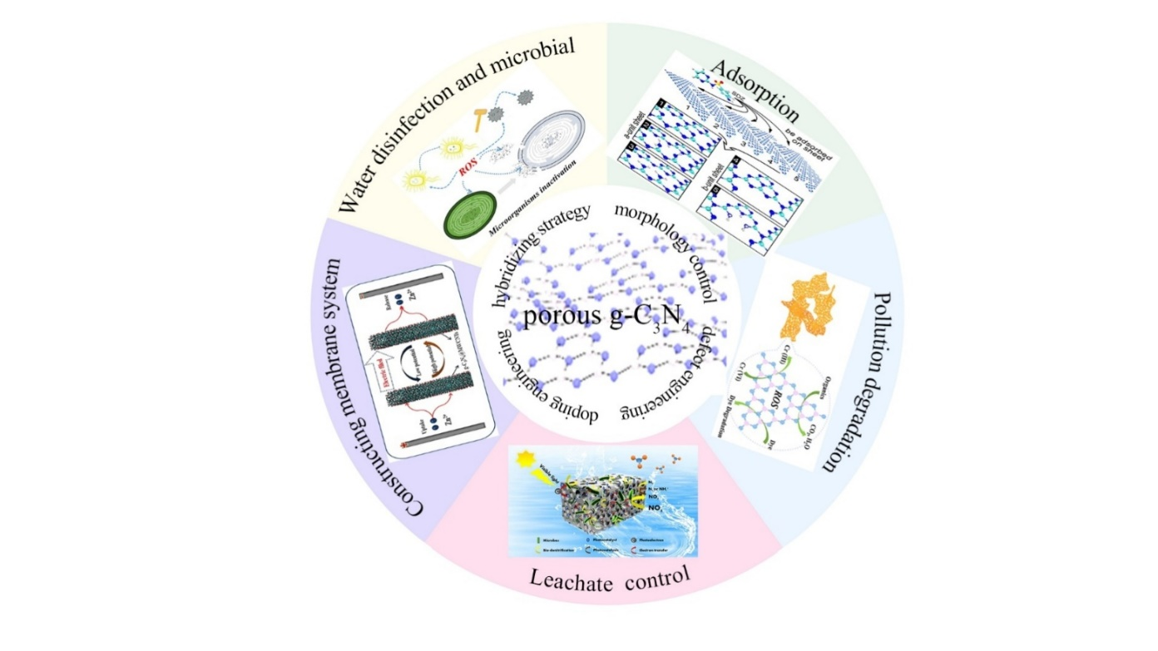

Fig. 1 The illustration of the modification and applications for water treatment over porous g-C3N4 nanomaterials.

**2.** Functional modifications

There are two ways to synthesize PCN. The first one uses nitrogen-rich precursors to directly fabricate PCN with a template or intermolecular force, which belongs to the bottom-up method. This method can avoid the planar atomic structure destruction and is mainly used until now. The second is chemical exfoliating or thermal oxidizing bulk g-C3N4, which belongs to the top-down method. The typical synthetic methods and properties of PCN are listed in Table 1 and no more detailed expound. However, poor visible light utilization and ultrafast carrier recombination of PCN still limit its application. Therefore, in this part, we mainly focus on the functional modifications, including morphology control, defect engineering, doping engineering, hybridizing strategy and anchoring single atom, to solve these problems and enhance the catalysis activity.

Table 1 Summary of the synthesis strategies about PCN.

|  |  |  |  |  |  |  |  |
| --- | --- | --- | --- | --- | --- | --- | --- |
| Synthesis strategies | Synthetic method | Template/Etchant | Precursor | Morphology | Sample | Application | Ref |
| Bottom-up approaches | Hard template methods | mesoporous silica | urea and dicyandiamide | nano-layer with irregular holes | mesoporous CuO/g-C3N4 | Hg(II) photoreduction | 32 |
| KIT-6 | cyanamide | ordered mesoporous nanocasted | m-CN | RhB degradation | 33 |
| crab shells | urea | porous nanofibers | g-C3N4-T | U(VI) elimination | 34 |
| calcium carbonate | melamine | Nanoporous sheets | npg-C3N4 | MB adsorption and degradation | 35 |
| Soft template methods | NH4Cl bubbles | ammonium chloride and melamine | Nanoporous sheets | CN-Cl | TC degradation | 36 |
| CTAB | melamine | porous nanosheets | mpg-C3N4 | MB degradation | 37 |
| Supramolecular assembly | - | 2, 4-diamino-6-phenoxy-1, 3, 5-triazine | porous nanosheets | CM-xphO | RhB and TC-HCl degradation | 30 |
| Top-down approaches | Chemical exfoliation | K2Cr2O7–H2SO4 | dicyandiamide | porous nanosheets | Porous g-C3N4 | RhB degradation | 38 |
| H2SO4 and HNO3 | melamine | porous ultrathin nanosheets | PUOCNs | methyl orange degradation | 39 |
| Thermal oxidation | - | ammonium persulfate and melamine | porous nanosheets | D-g-C3N4 | Meropenem removal | 40 |
| urea and ammonium oxalate | ultrathin porous layers | OPCN | bisphenol A removal | 41 |

## 2.1 Morphology control

Generally, nanostructured g-C3N4 semiconductors with unique morphology attract more attention on account of their specific surface area. For instance, macro-/meso-porous g-C3N4 with nanosheets, nanofibers, and nanospheres structure have been explored to meet practical applications. In numerous reports, ultrathin nanosheets structure exhibits superior photocatalytic performance, especially shorter charge migration distances 42. Therefore, many efforts have been explored to synthesize two-dimensional (2D) ultrathin g-C3N4 nanosheets 43, 44. The interlaminar van der Waals force of g-C3N4 is weak, therefore, it is possible to synthesize ultrathin g-C3N4 nanosheets with chemical exfoliation. Different etchants, such as strong acids 45, 46, isopropyl alcohol 47, and other highly oxidizing materials 48, can change the morphology and porosity of PCN due to the different reaction mechanisms. In the treatment of K2Cr2O7-H2SO4, hydroxyl and carboxyl groups were produced through the acid oxidation. The hydrophilic functional groups were inserted the carbon nitride interlayers and converted into chinone groups, finally forming porous structures 38. Wan et al. prepared ultrathin g-C3N4 through dissolving BCN in concentrated H2SO4 46. The rapid and intense heating effect caused by mixing of water and H2SO4 made the hydrogen bonds broken to form ultrathin nanosheets and the etching of H2SO4 caused the porous structures formation. The pH of urea solution was adjusted with 0.1 M hydrochloric acid and ultrathin PCN nanosheets were obtained by the exfoliation of isopropyl alcohol 47. Acidification, drying and self-assembly could prompt the gaps formation between the adjacent urea molecules. Besides, during urea condensation, abundant NH3 and CO2 gas bubbles would be produced and eventually burst. The stripping process between the acidified urea molecules benefited the porous structure formation 49. Besides, Zhou et al. synthesized ultrathin g-C3N4 with hierarchical pores nanosheet (P-mMCNNS) via calcining dicyandiamide and NH4Cl in a nitrogen atmosphere 50. The decomposition of NH4Cl resulted the NH3 and HCl formation, which can save as gas bubbles templates to form porous structure. Besides, the nitrogen atmosphere benefited macro-mesopores production. And the hierarchical porous nanosheets showed fascinating photocatalytic performance, which could be ascribed to the large surface area, multi-mass transport channels and short charge transfer distance (Fig. 2a).

Recently, supramolecular self-assembly has also gained more attention owing to the specificity and reversibility of hydrogen bonds, which is released to form well-defined porous structures 51. The melamine-cyanuric acid via hydrogen bonding is often used as a precursor to prepare PCN in supramolecular self-assembly 30. The hydrogen bonding leads to the formation of supramolecular complex, and the N atoms on the heptazine ring are substituted by the C atoms to form CN structure after the supramolecular complex polycondensation (Fig. 2b). Moreover, the morphology and structure will change due to the steric hindrance of substituent and heteroatom. Liu et al. synthesized mesoporous g-C3N4 nanosheets utilizing a fresh supramolecular precursor 52. The research proposed the formation of melamine-cyanaurate complex via hydrothermal treatment for dicyandiamide, and the complex was easily converted into PCN with ultrathin nanosheets by calcination. The bandwidth and photocatalytic activity of prepared material were narrower and higher.

As we all known, large specific surface area is in favor of catalytic ability improvement owing to providing more active reaction sites. The catalytic performance of most PCN is also unsatisfactory. Therefore, in this section, more morphology control strategies and methods have been reviewed in order to obtain more satisfactory catalytic performance. These methods can shorten charge migration distances and enlarge multi-mass transport channels. In the future, more advanced methods and strategies to synthesize PCN should be explored to meet the demands of highly efficient catalytic performance.

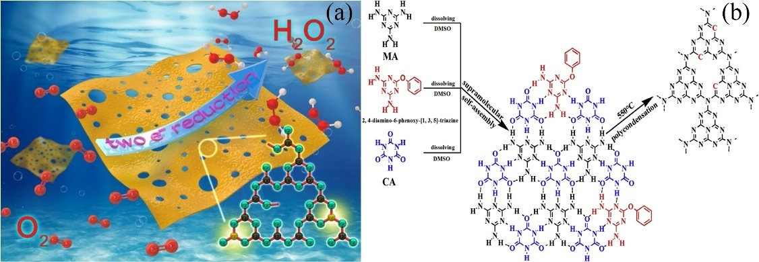

Fig. 2 (a) Possible mechanism for highly efficient H2O2 production over P-mMCNNS-25. Reorganized from ref 50 with permission from Elsevier, copyright 2020. (b) The reaction path for the modified-CN materials via supramolecular complexes polycondensation. Reorganized from ref 30 with permission from Elsevier, copyright 2020.

## 2.2 Defect engineering

The existence of defects on the surface not only provides plentiful active sites but also prevents the rapid recombination of photo-carrier. Considering the chemical composition of g-C3N4, there are two types of defects including nitrogen defects and carbon defects commonly existed in g-C3N4. The nitrogen defects are produced by some reactions under high-temperature calcination. Here, mesoporous g-C3N4 with nitrogen vacancies was synthesized by utilizing mixture of melamine-urea as the precursors 53. The porous structure and surface N defects were formed with increased proportion, which might be due to the release of additional ammonia gas when urea was calcined. Besides, the intensive separation efficiency of carriers was attributed to the photogenerated electrons capture in surface N defects. Wang et al. prepared a series of nitrogen defected PCN nanosheets via one-step method in a self-created atmosphere 40. Specifically, the melamine and finely grounded ammonium persulfate were calcined at 600 °C. The obtained compound was heated at 500, 550, and 650 °C with the same condition, respectively. Under the thermal treatment, ammonium persulfate was decomposed into SO2, NH3, and O2. In the presence of SO2, the tri-s-triazine units were polymerized to synthesize g-C3N4, and the N atom located on the tri-s-triazine unit reacted with NH3 molecule to produce N2C defect 54. Zhai et al. put forward a five minutes thermal treatment method to obtain PCN with large amount of defects, which showed remarkably extended light absorption (Fig. 3a) 55. Density functional theory (DFT) calculations indicated that the cyano groups resulted the higher absorbance and nitrogen vacancies induced light absorption region red shift. It is anticipative to provide guidance for logical modification of nanomaterials.

Besides, carbon vacancy in g-C3N4 has also been studied. Some carbon species of g-C3N4 may react with NH3 at high temperature resulting carbon vacancy’s introduction. For example, Liang et al. reported that g-C3N4 with in-plane holes (HGCN) nanosheets were synthesized via thermally treatment in NH3 atmosphere 56. The induced carbon vacancies made the light absorption band extend into the near-infrared (NIR) region and suppressed recombination of charge carriers. Besides, Liu et al. prepared porous ultrathin g-C3N4 nanosheets with carbon vacancies (Cv-CNNs) via simple two-step thermal technology in Fig. 3b 7. In the presence of C vacancies, exposed N atoms were transformed into -NH2 groups, which not only extended the lifetime of the excited states, but also enhanced the CN sheets dispersion. Meanwhile, the plane structure was changed due to C vacancies, which enhanced the adsorbability of Cv-CNNs for sulfadiazine (SDZ). In another case, a porous defective g-C3N4 was synthesized by utilizing urea nitrate as a gas template for the first time (Fig. 3c-e) 57. Adding urea nitrate to the CN polymerization process was also in favor of defect exposure and porous structure formation. Adding N, H, and O atoms into the g-C3N4 matrix improved electron polarization effects to increase the charge separation efficiency. The specific surface area and oxygen adsorption were improved owing to the presence of defects. Therefore, porous defective g-C3N4 could produce more active radicals to improve the overall photocatalytic performance.

If the original periodic arrangement of basic units in g-C3N4 are disrupted, defects will be formed. The defects can capture carriers to inhibit their recombination and provide active sites to accelerate reaction. Besides, for photocatalysis, the visible light absorption region can be extended. The surface defect with porous structure improves catalytic performance of g-C3N4. However, analyzing the formation mechanism of defects from the perspective of computational theory is still a challenge and need further exploring.

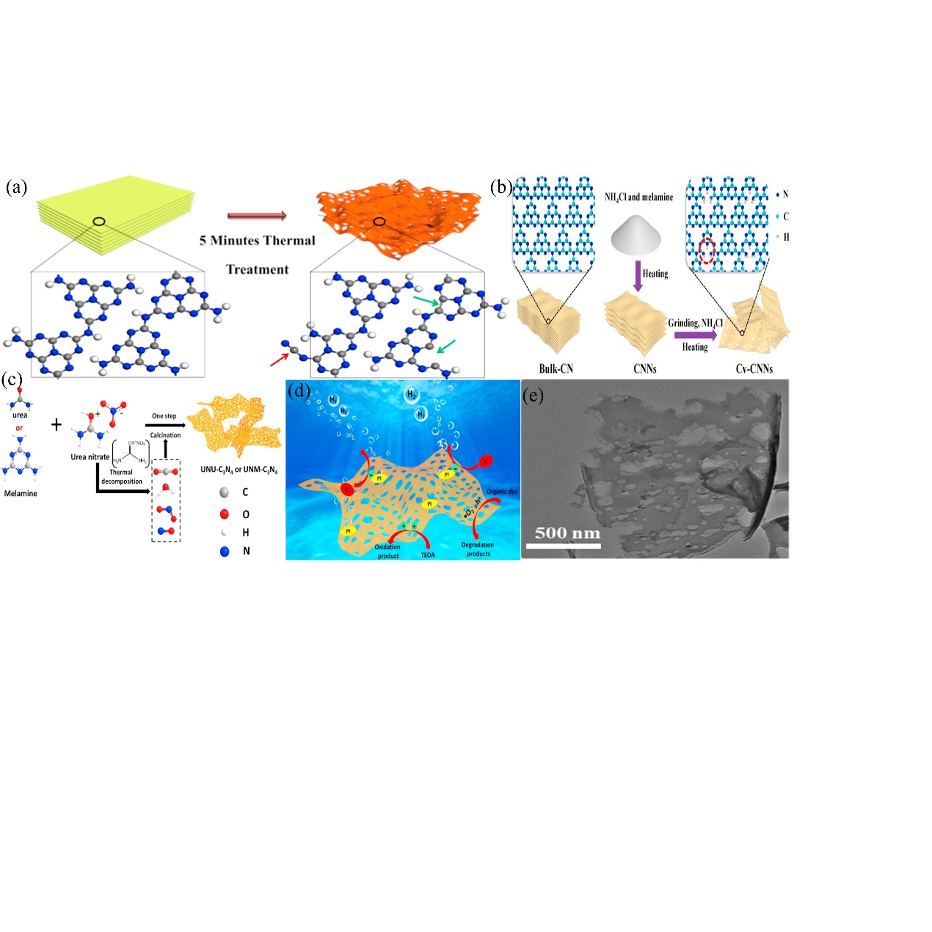

Fig. 3 (a) After the quick thermal treatment, the morphology change and theoretical calculated dielectric function with the presence of cyano group and nitrogen vacancies. Reorganized from ref 55 with permission from Elsevier, copyright 2018. (b) The synthetic process of Cv-CNNs. Reorganized from ref 7 with permission from Elsevier, copyright 2020. (c) Illustration of the synthetic route for the UNU-C3N4 or UNM-C3N4 nanosheet; (d) Schematic illustration of the UNU-C3N4 (or UNM-C3N4) during H2 evolution process and degradation process; (e) TEM images of UNM-C3N4. Reorganized from ref 57 with permission from Elsevier, copyright 2020.

## 2.3 Doping engineering

Doping heteroatoms has been considered as an efficient way to extend the absorption edge and prevent the electron-hole rapid recombination of the catalyst 58, 59. Heteroatoms can replace lattice or exist in the in-planar cave of g-C3N4 to realize doping 60. Doping PCN with nonmetals elements can modify its electronic structure to enhance the photocatalytic activity, such as boosting light absorption, accelerating charges transport, and prolonging carrier lifetime 61. For example, B2O3 was used as an excellent dopant to alter the structure of g-C3N4 62. The element B replaced the H on the amino group of the structure in g-C3N4. According to the DFT calculations, the delocalized big π bonds were formed among the displaced carbons, and the hexatomic rings benefited the catalyst electrical conductivity 63. Bao et al. proposed a thermal treatment to synthesize porous carbon-doped g-C3N4 (NSs-APAM) 64. The carbon doping was verified by the increased ratio of carbon to nitrogen in NSs-APAM. Furthermore, NSs-APAM red-shifted absorption edge and decreased bandgap energy, demonstrating that doping carbon atoms outspreaded the π-electron conjugated structure and then conducted the visible-light harvest. Zhang et al. synthesized dual-oxygen-doped porous g-C3N4 (OPCN) via the ammonium oxalate and urea thermal copolymerization 41. The N1’ and N4’ atoms of sp2-hybridized melem units were simultaneously replaced by O atoms. According to DFT calculations, the charge separation and transfer of OPCN increased due to the surface related conjugated delocalized systems, which benefited the adsorption of O2 and interfacial contact with organics. Therefore, OPCN showed enhanced removal efficiency for bisphenol A, chlorophenols, phenols, and dyes.

Sulfur atom has been verified to substitute edge N atoms in g-C3N4 to adjust the electronic structure 65. Cao et al. synthesized sulfur doping ultrathin porous carbon nitride nanosheets (SCNNSs) containing carbon vacancies through a one-step thermal polymerization of thiourea without extra templates 66. The SCNNSs provided plenty active sites and increased the charge carrier separation rate. Zhang’s group synthesized nitrogen-doped PCN nanosheets (N-CNS) via N2 high-temperature treatment following carbon coating of g-C3N4 nanosheets by hydrothermal 67. The both sides of g-C3N4 were coated carbonized glucose via a hydrothermal treatment, which benefited the pores production. Phosphorus, as an oxyphilic element, can enhance the adsorption for O2 in the process of oxygen reduction when it is introduced into the g-C3N4 catalyst. In the heptazine rings of the CN units, the C sites and vacancies were preferentially substituted by P, because the latter lower the formation energy, thereby resulting in enhanced carriers separation and reducing the amount of unpaired electrons 68. In addition, halogen elements have also been doped to enhance the photocatalytic performance 69-72. Melamine treated by different halogen acids had been used as tailored supramolecular precursors to synthesize halogen elements doped g-C3N4 with controlled morphologies and optical properties 73.

Besides, metal elements, including alkali metals and transitional metals, have been induced into the g-C3N4 framework to promote the catalytic activity. Metal-ion doping can narrow the energy gap, accelerate the charge mobility and enhance carrier separation. Due to the strong interactions between the lone pairs of electrons in the nitrogen pots of g-C3N4 and metal cations, it is easy to capture metal ions into g-C3N4. Jiang et al. prepared a serious of alkali metal ions (Li+, Na+, and K+) doped PCN with facile high-temperature treatment 74. The electronic structures, including band gap, conduction bands, and valence bands, were tailored by doping of alkali metal ion, which benefited the utilization of visible-light and charge excitation. Miao et al. firstly prepared layered porous Fe-doped g-C3N4 catalyst through tuning the pyrolysis duration time 75. Pyrolysis treatment split bulk structure into multi-layer porous structure, which enhanced the catalytic activities according to the first-order kinetic model analysis. In addition, the active sites would add due to the Fe doping, which enhanced the performance in Fenton-like reactions (Fig. 4a). Co/Mo co-doped mesoporous g-C3N4 was one-pot synthesized by straightforward template-free method 76. Incorporating Mo atoms accelerated the decomposition of g-C3N4, leading to the mesopores creation. The DFT calculations proved that Co/Mo co-doping extended the light absorption and narrowed the bandgap of catalyst. The inner optical characteristics of photocatalyst were measured by optical simulation in Fig. 4b-c, illustrating that bimetallic co-doping and mesoporous structure exhibited stronger light absorption capability. In addition, utilizing calcination-refluxing method to synthesize the porous Mn doped g-C3N4 (g-C3N4-Mn-H) photocatalyst was also proposed by Wang and his group 77. The pore structure of g-C3N4 was etched through the acid-oxidation. In Fig. 4d, the computational modeling revealed the distributive location of the lowest unoccupied molecular orbital (LUMO) and the highest occupied molecular orbital (HOMO) in the different regions over g-C3N4-Mn-H, which facilitated the separation of photo-induced carriers owing to the atomic layout and molecular orbital distribution affected by Mn doping and carboxyl modification.

In brief, doping heteroatoms can adjust the electronic structure because of the hybridization between dopant orbitals and the molecular orbitals of g-C3N4. The adjusted structure facilitates the separation of photo-induced carriers and extends the absorption edge. Many heteroatoms have been used to construct doped PCN and doping metal elements can alter the morphology of PCN, which is beneficial to contact with morphology control. Therefore, combined effect of doping engineering and morphology control engineering is needed to study further. Besides, the computational modeling shows potentials in this field. Combining DFT calculations or other computational modeling is worth studying for doped PCN development.

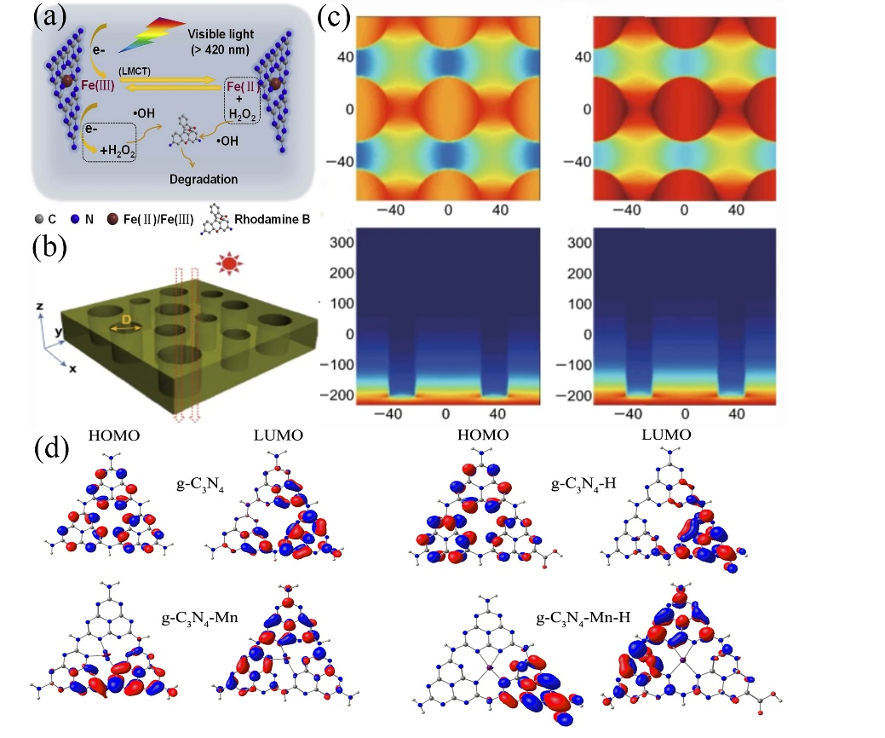

Fig. 4 (a) Reaction schematic diagram of Fe-C3N4. Reorganized from ref 75 with permission from Elsevier, copyright 2020. (b) Simulation model of Mo-MCN; (c) Electric feld intensity distribution (Color varied from blue to red reveal the electric field intensity proving). Reorganized from ref 76 with permission from Springer, copyright 2019. (d) HOMO and LUMO distributions of g-C3N4, g-C3N4-H, g-C3N4-Mn and g-C3N4-Mn-H catalysis. Reorganized from ref 77 with permission from Elsevier, copyright 2017.

## 2.4 Hybridizing strategy

Hybridizing strategy has been considered as the most common and simple method to promote the surface charge separation. In general, hybridizing strategy is achieved by coupling with narrow-bandgap semiconductor and depositing co-catalyst 78 and the two ways show different carrier separation mechanism. When coupling with semiconductor, heterojunction will be constructed. The two semiconductors with unequal band structure can be stimulated to produce photo-induced electrons, which can be transferred to avoid recombining. The relevant detail has been reviewed by Yu’s group 79. Usually, there are about three main forms of heterojunctions about coupling PCN with semiconductor, including conventional type-II heterojunctions, p–n heterojunctions, and Z-Scheme heterojunctions. For example, a hierarchically porous type-II heterojunction was synthesized with zinc oxide (ZnO) and g-C3N4 80. The photogenic electrons from the conduction band (CB) of g-C3N4 transferred to the CB of ZnO, while the photogenerated holes from the valence band (VB) of ZnO migrated to the VB of g-C3N4 under light irradiation, resulting in electron-hole pair’s separation. The composite showed high photodegradation for Rhodamine B (RhB) and phenol. However, the enhanced electron-hole separation through type-II heterojunction is not sufficient to overcome the ultrafast electron-hole recombination on the semiconductor. Thus, a p-n heterojunction has been proposed to accelerate the electron-hole migration and increase the photon-generated electrons lifetime by providing an additional electric field. Li et al. proposed p-n type Bi5O7I-modified PCN heterojunction with excellent catalytic ability, which was nearly 30 times higher than that of pure g-C3N4 81. However, in above heterojunctions, both the reduction and oxidation progress occur in lower reduction and oxidation potentials resulting in the redox ability sacrificial. Therefore, Z-Scheme heterojunction has been proposed to maximize the redox potential of the heterojunction systems. Lv et al. combined PCN with BiOBr to construct Z-Scheme heterojunction to restrain the photo-induced carrier recombination 82. The photogenic electrons from the CB of BiOBr were easily transferred to the VB of PCN. The transmission electron microscope (TEM) images suggested that BiOBr nanolayer was scattered over the surface of PCN nanosheets, and the 20% PCN/BiOBr showed the highest photocatalytic degradation of methylene blue (MB).

On the sides, when depositing co-catalyst, the stability and selectivity of main catalyst in the catalytic progress have been promoted 83. Although co-catalyst is an intrinsically inactive material, it can collect the photogenerated charge carriers and provide more active sites because of its superior conductivity or its ability to store electrons 84. In a word, co-catalyst can prevent the electron-hole recombination of main catalyst. Co3O4 quantum dots saved as co-catalyst depositing on PCN by a facile annealing process to enhance catalytic performance 85. Because of the strong interaction, abundant pores were in-situ produced during this process. More importantly, this work provided a new strategy for designing co-catalyst on PCN. Besides, AuCu alloy nano-particles (NPs) used as co-catalyst to modify ultrathin PCN nanosheets 47. The light absorption was enhanced because of the local surface plasmon resonance (LSPR) of Au NPs, which accelerated the C-C combination process in the production of ethanol. In addition, Chen et al. loaded ultrathin MoS2 as a co-catalyst on PCN to enhance photocatalytic performance 86. Ultrathin MoS2 extracted photo-induced electrons from g-C3N4 and increased adsorption sites for RhB.

In the conclusion, hybridizing semiconductors or co-catalyst is a mature strategy to suppress the recombination of carrier. Combining with semiconductors can regulate the band structure of composites and the electron transport path at the interface to enhance charge carrier’s separation. In addition, co-catalyst can provide more active sites and trap photo-induced electrons to reduce carrier recombination. Besides, the specific characters of semiconductors and co-catalyst are also good for the catalytic performance improvement. The wonderful catalytic ability shows the potential in water treatment application.

## 2.5 Anchoring single atom

Single atom catalysts, with maximum atoms utilization, well-distributed active sites, and strong metal-support interactions, have become a new frontier in catalysis 87, 88. However, single dispersed atoms are easy to aggregate large clusters, and a suitable support can enhance the stability and dispersity of single atom catalysts 89. Porous 2D materials provide sufficient space as an excellent support to anchor single atoms 90. Besides, g-C3N4 is also widely used to accommodate single atoms because its six-fold cavity can provide an ideal position 91. Therefore, it is a research frontier for anchoring single atom onto the PCN network via coordination bonds. For instance, Yang et al. reported in-situ growth strategy to implant single-atom cobalt in pCN 92. The photocatalytic performance of single-atom cobalt dispersed pCN are enhanced because formed chemical bonding facilitates charge separation and transfer. Moreover, single-atom cobalt can efficiently increase electron density and enlarge light absorption. The OTC degradation of Co(1.28%)-pCN is about 3.7 times than pristine pCN. Li et al. constructed single-atom silver incorporated g-C3N4 catalyst 91. According to the density functional theory (DFT) calculations, single-atom silver was anchored in the six-fold cavity of g-C3N4 and the formed N-Ag bonding solve the metal agglomeration under higher temperature. Particularly, the research testified Gibbs free energy of the intermediate state (ΔGH*) was upgrading because the pyridinic N atoms adjacent to the Ag occupied six-fold cavity, which was favor of hydrogen evolution reaction. The work develops a new strategy to design catalyst with the ultrahigh photoactivity and photothermal stability. Zhao et al. anchored single-atom platinum (Pt) on holey ultrathin g-C3N4 nanosheets (Pt-CNHS) as cathode electrocatalysts for Li-O2 batteries 93. The synergism between single-atom Pt and CNHS enhanced the battery performance such as providing excellent rechargeability and high specific capacity.

Compared with conventional metal nanoparticles, single-atom catalyst can achieve maximum atom-utilization efficiency to exhibit excellent stability and catalytic activity. The catalytic activity of single-atom catalyst is ascribed to the interaction between single-atom with coordinating atoms on supports. Forming strong bonds endow single atom with stability, making them to overcome the high aggregation propensity. PCN with porous structure and N-rich cavities is beneficial for anchoring single atom. Especially, Li et al. testified that anchoring single-atom Ag on g-C3N4 can solve the aggregation problem under high temperature, which is provided new guidance for single-atom catalyst design. Although anchoring single atom is a new frontier in catalysis, the preparation of single atom is difficult and improving the dispersibility of single-atom is also a challenge. It is also necessary to taking efforts to research the structure and catalytic mechanism via theoretical calculation.

# 3. The application of FPCN in water treatment

According to these functional modification in section 2, PCN with large surface area and unique energy band positions gain widely attention in the environmental pollution treatment. The large surface provides plentiful active sites in the reaction progress to improve mass transfer process. In addition, the unique electronic structure and adjusted energy band positions benefit the carrier separation and promote the production of more active radicals for photocatalytic degradation reaction. Recently, more researchers have paid attention to the water disinfection and microbial control via g-C3N4 based nanomaterials. In this part, we highlight the recent water treatment applications based on PCN.

## 3.1 Adsorption

Adsorption is a simple technique to remove the heavy metals and organic pollutants in wastewater treatment, and it is widely used as a pretreatment approach for the large scale elimination of contaminant 6. In the adsorption process, strong surface complexes are generally formed owing to electrostatic attractions, H-bonding, pore-filling, hydrophobic effect, and π-π electron donor-acceptor coactions of organic molecules 94. When the adsorption materials are added, the left pollutants will be quickly adsorbed on the surfaces and then further be degraded. For example, Zhu’s group proposed a novel nanoporous g-C3N4 (npg-C3N4) showing enhanced adsorption activity 24. When the proportion of thiourea was about 80%, the surface area over npg-C3N4 was about 46.7 m2 g-1 with pore width around 3.7 nm, which exhibited 40.0% of MB adsorption from the solution in Fig. 5a-c. Besides, a simple two-step thermal method was proposed by Liu and his group to synthesize porous ultrathin g-C3N4 nanosheets with carbon vacancies (Cv-CNNs) 7. This work firstly revealed the SDZ adsorption capability of Cv-CNNs by quantum mechanical simulations (Fig. 5d-e). The result indicated that the improved adsorption capability was ascribed to the synergy of large surface area and carbon vacancies, which could affect diverse levels of H saturation. Accordingly, enhanced adsorption was beneficial to the elimination of low-concentration antibiotics, which showed potential practical application for micropollutants degradation in water. Zhu’s group fabricated a 3D g-C3N4/TiO2 heterojunction, which enhanced the adsorption efficiency and offered more active sites to shorten the mass transfer distance in surface reaction 95. The optimized surface area of 3D g-C3N4/TiO2-57% was 9.8 times larger than BCN, while the MB adsorption (2.916 mg/g) was 10.5 times superior to BCN (Fig. 5f). The increase of the 3D structured surface area improved the MB adsorption ability.

Most of heavy metals are removed by adsorption, such as cadmium (Cd), zinc (Zn), copper (Cu), lead (Pb), and mercury (Hg) etc., which have affected the environmental system and posed threats to living creatures. Moreover, it is reported that trace level heavy metals existed in drinking water, including Cd (0.003 mg/L), Cu (2.0 mg/L), Pb (0.01 mg/L) and Hg (0.001 mg/L), causing significant health issues to humans 96. In terms of heavy metals removal, the system conditions (i.e., pH and surface functional groups) will affect the adsorption process. Specifically, solution pH can affect the surface charge of prepared samples and heavy metal ions distribution, resulting the electrostatic interaction between catalysts with contaminant 97. Wang’s group demonstrated that different pH affected the adsorption for Cr over calcined CoFe-LDH/g-C3N4 98. At pH = 2.0, the Cr (VI) were completely removed within 100 min. This was because the negatively charged Cr (VI) was adsorbed to the positively charged calcined 50%-CoFe-LDH/g-C3N4 under strong acidic condition. Besides, the hard ferrites nature of composites with high remanence and coercivity (Fig. 5g) benefited the composites separation from wastewater. Gu et al. fabricated LS-C3N4/CWS catalyst consisting of lignosulfonate functionalized g-C3N4 and carbonized wood sponge, which exhibited high adsorption capability for Pb2+ (659.6 mg/g), Cd2+ (329.1 mg/g), and Cu2+ (173.5 mg/g) 25. Besides, the removal rates towards these metal ions were similar, which would increase with increasing pH value (2.0-6.0) (Fig. 6a-b). More importantly, it was easy to recover the spent LS-C3N4/CWS, which still maintained high removal efficiency after 10 cycles. Besides, LS-C3N4/CWS was used as an ultrafiltration membrane to sequentially treat abundant model wastewater, in order to make the concentration of target metal ions below the allowed level in drinking water (Fig. 6c). In addition, most metal ions were regarded as Lewis base while N-/P-/S-containing functional groups were regarded as Lewis acid. The Lewis acid-base interaction boosted the selective absorption capacity of metal ions. Therefore, Hg2+ was removed through the adsorption of S-doped C3N4/graphene oxide 3D hierarchical framework 99. Theoretical calculations and experimental results indicated the excellent adsorption selectivity of Hg2+ could be attributed to the enhanced electrostatic forces and the coordination bonding though S/Hg in tubular structure (Fig. 6d).

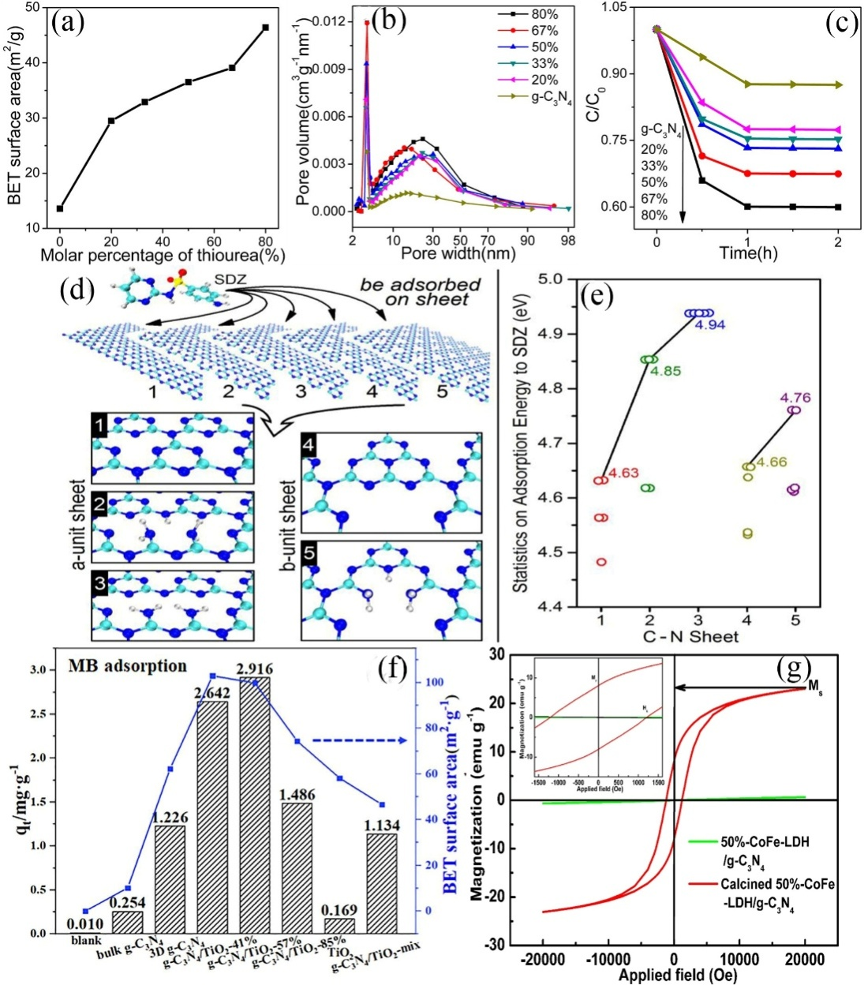

Fig. 5 (a) The BET surface area; (b) pore size distribution and (c) the MB adsorption of BCN and npg-C3N4 with different thiourea molar percentages in the dark. Reorganized from ref 24 with permission from American Chemical Society, copyright 2013. (d) CN sheets used to adsorb SDZ; (e) Adsorption energy of SDZ over Cv-CNNs. Reorganized from ref 7 with permission from Elsevier, copyright 2020. (f) The MB adsorption ability and BET surface area over g-C3N4/TiO2. Reorganized from ref 95 with permission from Elsevier, copyright 2019. (g) The VSM of 50%-CoFe-LDH/g-C3N4 and calcined 50%-CoFe-LDH/g-C3N4. Reorganized from ref 98 with permission from Elsevier, copyright 2020.

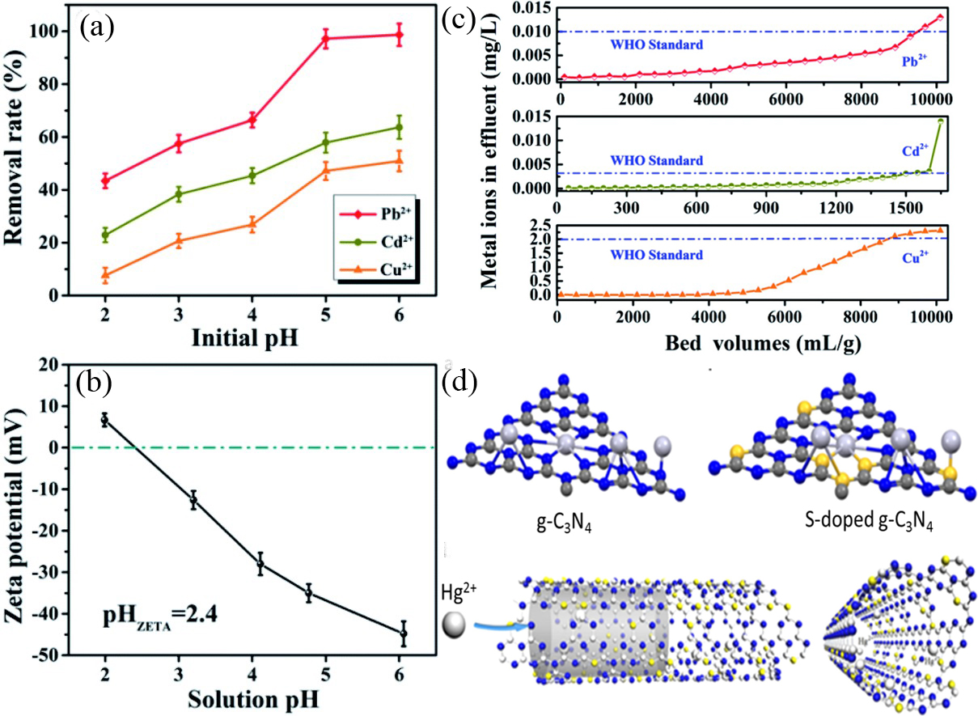

Fig. 6 (a) The removal rate for Pb2+, Cd2+ and Cu2+ with different initial pH; (b) Zeta potentials with different solution pH; (c) Successive separation performance for Pb2+, Cd2+ and Cu2+ on LS-C3N4/CWS. Reorganized from ref 25 with permission from the Royal Society of Chemistry, copyright 2020. (d) Possible coordination modes of Hg to g-C3N4 and S-doped g-C3N4 and the diffusion process of Hg2+ inside a S doped g-C3N4 mesopore. Reorganized from ref 99 with permission from Elsevier, copyright 2020.

Large surface area and induced vacancies can provide more active sites to improve adsorption activity. Meanwhile, the contact interfaces intimacy and synergistic effect in heterojunction can also enhance the adsorption performance. Therefore, more FPCN nanomaterials with excellent adsorption capacity should be studied for wastewater treatment.

## 3.2 Pollutant Degradation

PCN as a super catalyst has been widely used in photocatalytic degradation of pollutant. The electrons of PCN are excited under visible light to form strongly radicals such as superoxide radical (•O2-), hydroxyl radical (•OH) and singlet oxygen(1O2) via different reaction, which play an important part in the complex degradation reactions. Recently, with the research moves deeply, PCN has been used in other AOPs, like PEC, and Fenton-like reaction. For example, by utilizing a facile electrophoretic deposition method, PCN can couple with other materials to form highly active photoanode, which achieved high PEC pollutant degradation 100-102. It is also documented that PCN shows excellent H2O2 production 103, which plays the important role in Fenton-like degradation. Coupling PCN with transition metal-based materials extends the light absorption range, accelerates charge separation, and activates photo-Fenton (-like) reactions for excellent degradation performance 104. In addition, PCN can enlarge specific surface area, improve stability and eliminate active metal irons leaching in persulfate activation. As an external nitrogen source, it can also provide active sites such as quaternary-N, pyrrolic-N and pyridinic-N 105. Therefore, in this section, the FPCN nanomaterials applied in AOPs have been reviewed to control different contaminant.

### 3.2.1 Reduction of pollution

Reduction has been considered as a popular technology to degrade pollutant owing to the strong operability and high efficiency. The most important principle in reduction is to reduce the highly toxic constituent to the less toxic one 9. Apart from adsorption method mentioned earlier, heavy metals ions can also be removed by reduction. For example, Feng et al. designed Bi@BiOCl/PCN heterostructure and applied in Cr (VI) photo-reduction 106. The Cr (VI) were photo-reduced to Cr (III) over Bi@BiOCl/g-C3N4 with reduction rate of 0.02212 min-1. Calcined CoFe-LDH/g-C3N4 composite was used to remove Cr (VI) via the synergy of adsorption and photocatalysis 98. It was reported that 60% of Cr (VI) (50 mg/L) were adsorbed over CoFe-LDH/g-C3N4 in 10 min and then Cr (VI) removal efficiency reached 100% in 90 min. In the photocatalysis progress, •O2- radical played the important part. From the above-mentioned results, the high valent metal ions, Cr (VI), was reduced to low valent Cr (III) according to photocatalytic reduction process, which decreased the toxicity of metal ions. In addition, some researches showed that citric acid and oxalic acid 107, even some organics 77, 108 increased the Cr (VI) photo-reduction efficiency because they could consume h+ to accelerate photo-generated electron-hole charge separation. Therefore, synergetic degradation between organics and heavy metal became a trend.

In addition, nitroaromatics have been proved to damage water environment and are difficult to completely remove owing to the strong stability and hard-biodegradation 109. Catalytic reduction has been considered as an efficient method to reduce nitroaromatics. Although noble nanoparticles have been widely used in nitroaromatics reduction, it is essential to choose proper supports to immobilize these nanoparticles because of their high aggregation. The amine groups on the surface of PCN can anchor metal nanoparticles to enhance the dispersity, stability and catalytic activity 110. Hence, PCN can be used for nitroaromatics reduction. For example, Qin et al. designed PDA-gC3N4/Au catalyst to apply in highly efficient nitroaromatics reduction by NaBH4 110. The catalyst exhibited excellent catalytic activity with a 0.0514 s−1 rate constant and 545.60 h−1 turnover frequency (TOF) for 4-nitrophenol (4-NP) reduction. Hu et al. synthesized 2D Rh/Fe3O4/g-C3N4-N compound, which showed excellent catalytic performance towards transferring nitroarenes into relevant anilines in water via hydrogenation 111. After 12 recycle, the catalytic property had obvious decrease. This research provided a guide for further catalytic reduction of various noble metals. Balakumar et al. fabricated S-doped g-C3N4 assembled by gold nanoparticles, the obtained catalyst achieved effective conversion of 4-nitrophenol in catalytic reduction 112. It was reported that the catalytic efficiency obtained near 100% within 5 min due to the fast electron transfer reduction.

The FPCN shows the potential in the removal of heavy metal ions and nitroaromatics from aqueous solutions, and the adjusted band gap of g-C3N4 advances the visible light absorption and charge carrier separation, which are most vital for the catalytic reduction. In addition, in some research, organics can capture the photo-induced holes to improve the separation of photo-induced holes-electrons, benefiting the metal ions photo-reduction. Therefore, functional PCN material shows the potential in efficiently elimination of metal ions and nitroaromatics through adsorption-catalytic reduction processes.

### 3.2.2 Removal of dye

With the development of industrialization, dye wastewater has obtained significant attention, which brings huge risk to environment and human beings 113. FPCN, which is obtained by inducing amino groups or defect in PCN, benefits to the dye removal via physical adsorption or chemical interaction. For example, PCN showed excellent photo-degradation efficiency for both cationic MB and anionic methyl orange (MO) degradation, and •O2- were found to play primary role in photodegradation 114. Zhang et al. constructed porous graphene aerogel-g-C3N4 (GA-g-C3N4) heterojunction with the purification capacity of 83.0% for MB within 3 h irradiation. The adsorption capacity towards dye was enhanced and the photo-induced electron-hole recombination was diminished on account of the combination to form heterojunction, benefiting the photocatalytic performance 115. Since common g-C3N4 generally exhibitnegatively charged surface , they usually show higher adsorption capacity to cationic dyes than anionic dyes 116. Therefore, it is crucial to develop functional PCN catalysts with excellent degradation ability towards anionic dyes. The ultrathin PCN material with surface carbon defects exhibited 96.2% of RhB degradation efficiency 117. The main active species in the RhB photo-reduction system would be changed from •O2- over BCN to both •O2- and •OH over ultrathin PCN. Zhao et al. demonstrated an electrophoretic deposition method to deposit PCN/reduction graphene oxide (rGO) on nickel (Ni) foam (CNG-Ni) to form highly active CNG-Ni foam photoanode 100. CNG-Ni showed synergy between RhB removal and H2 evolution. RhB could serve as the sacrificial agent to capture photogenerated holes, resulting in more photo-induced electrons transferring to the cathode for H2 evolution (Fig. 7a). During the PEC process, the CNG-Ni exhibited potential in pollutant control and energy generation. Shen et al. prepared P, K co-doped PCN in vapor and self-producing NH3 atmosphere 118. XPS spectra revealed the substitution of C position by P atoms in g-C3N4, while K atoms might be combined with C or N to form new bridge (K-N, and K-C) (Fig. 7b). The bandgap and electronic structure were adjusted on account of the changing electron density around the C and N atoms. The bandgap energies (Fig. 7c) and XPS valence band (Fig. 7d) indicated the P, K co-doped g-C3N4 showed a highest valence band and the lowest bandgap energy, meaning a higher oxidation capacity, outstanding visible-light availability and charge excitation. Fig. 7e showed that the photocatalytic performances of P, K co-doped g-C3N4 for RhB elimination was distinctly improved, which was ascribed to the large surface area, lower bandgap energy and few recombination of photogenic carriers.

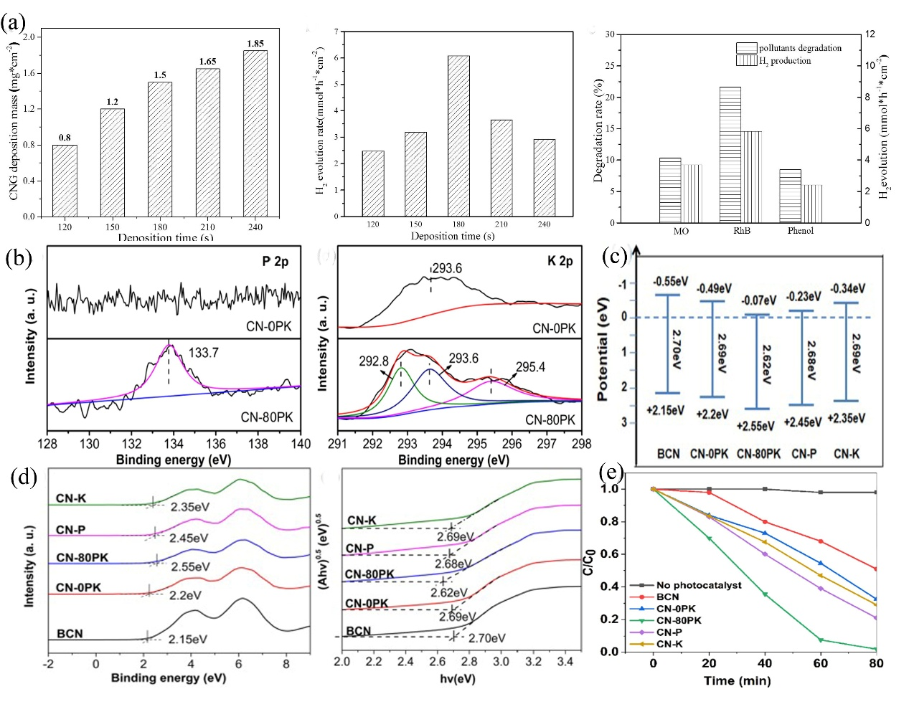

Fig. 7 (a) The amounts of loaded CNG1.0 on Ni foam with different deposition time, H2 evolution rates with different CNG1.0 amounts and the synergy between pollutant degradation and H2 evolution. Reorganized from ref 100 with permission from Elsevier, copyright 2019. (b) XPS spectra of P 2p and K 2p of CN-0PK and CN-80PK; (c) Band potential; (d) Valence potential and Bandgap energies of the original and modified g-C3N4; (e) RhB degradation efficiency of BCN and modified g-C3N4. Reorganized from ref 118 with permission from Elsevier, copyright 2020.

The PCN showed excellent degradation efficiency for dye in many studies. The light can reflect and scatter from nanoporous interiors of PCN. In addition, the large surface area can provide abundant catalytic active centers and visible light harvest, which is crucial for dye degradation via AOPs.

### 3.2.3 Removal of other organics

The cumulative concentration of pharmaceuticals and personal care products (PPCPs) around the surroundings has caused adverse effects on human health and natural ecosystems 119, 120. Therefore, abundant methods have been used to remove PPCPs. PCN has been widely used in AOPs to achieve efficient PPCPs removal. For example, Liang et al. proposed carbon quantum dots modified PCN to remove diclofenac (DCF) via photocatalysis process 11. DCF, as the most popular non-steroidal anti-inflammatory drugs (NSAIDs), has been extensively used 121. However, it is reported the traces DCF at concentration about μg/L or ng/L in the environment has adverse effects towards human health or ecosystem due to its low biodegradability 122. In this research, DCF was finally degraded by ring hydroxylation, ring closure and C-N bond cleavage (Fig. 8a-b). Wu et al. synthesized carbon dots/g-C3N4 hollow porous nanospheres (HCNS/CDs), which exhibited enhanced solar-light-driven PPCPs remediation, especially for naproxen (NPX) removal 3. The concentration of NPX in environment is in the range from 0.1 ng/L to 7.69 μg/L 123. It can be observed from Fig. 8c-d that the HCNS/CDs could decompose almost NPX within 5 min under natural sunlight irradiation and exhibited excellent removal performance in different NPX-containing water matrix. Besides, in Fig. 8e, HCNS/CDs was also used to treat other various types of PPCPs and the degradation efficacy was also higher than of HCNS. The high emissions of carbamazepine (CBZ) is at the level of ng/L to μg/L in aquatic ecosystems 124. Jiang et al. proposed porous 0D/3D NiCo2O4/g-C3N4 catalyst to improve CBZ degradation by PMS/photocatalysis system 125. CBZ was almost completely degraded within 10 min, and the TOC removal efficiency for raw secondary effluent from wastewater treatment plant (WWTP) has also showed the potential for practical sewage treatment. Sulfate radical (SO4•−), •OH and 1O2 played the important role in CBZ degradation. According to comprehensive toxicity assessment (Fig. 8f), the toxicity decreased with the CBZ degradation. Up to now, the concentration of sulfamethoxazole (SMX) detected in WWTPs has ranged from ng/L to μg/L, while even reach mg/L level from pharmaceutical industries 126. Liu et al. prepared PCN through introducing ammonia bicarbonate as pore former 127. In SMX degradation, •O2− and •OH played the main role in bond break, ring open, oxidation, and hydroxylation, thus resulting 93.37% of removal efficiency. Zheng et al. synthesized PCN doped with carbon and oxygen (COCN) through a facile single-step co-pyrolysis technology, which exhibited a 5.9 folds indomethacin degradation under visible light irradiation in comparison with original g-C3N4 128. C, O co-doping could change the π band state to extend the conjugation of π-electrons, therefore, COCN advanced the separation of photogenerated electron-hole and facilitated the harvesting of visible-light. Tetracycline (TC) has been widely used to kill or inhibit a few bacteria due to low cost and high antimicrobial activity 129-131. The concentration of TC obtained hundreds μg/L rang in surface water sources, ground waters, and even drinking water sources, while the concentration up to 2 mg/L in livestock wastewater 132. Porous noble-metal-free co-doped g-C3N4 (C/Ce-CN) was synthesized via supramolecular self-assembly to degrade TC 133. The TC photocatalytic removal efficiency over C/Ce-CN was about 2.6 times superior to that of pristine CN. The photoelectrical test (Fig. 9a-d) revealed that C/Ce-CN possessed faster charge transfer rate and longer lifetime of carriers. Yang et al. fabricated ultrathin PCN decorated with boron nitride quantum dots, which degraded oxytetracycline hydrochloride (OTC-HCl) via intensive exaction dissociation and charge transfer 134. Therefore, it provided a new insight to explore highly efficient and stable composite.

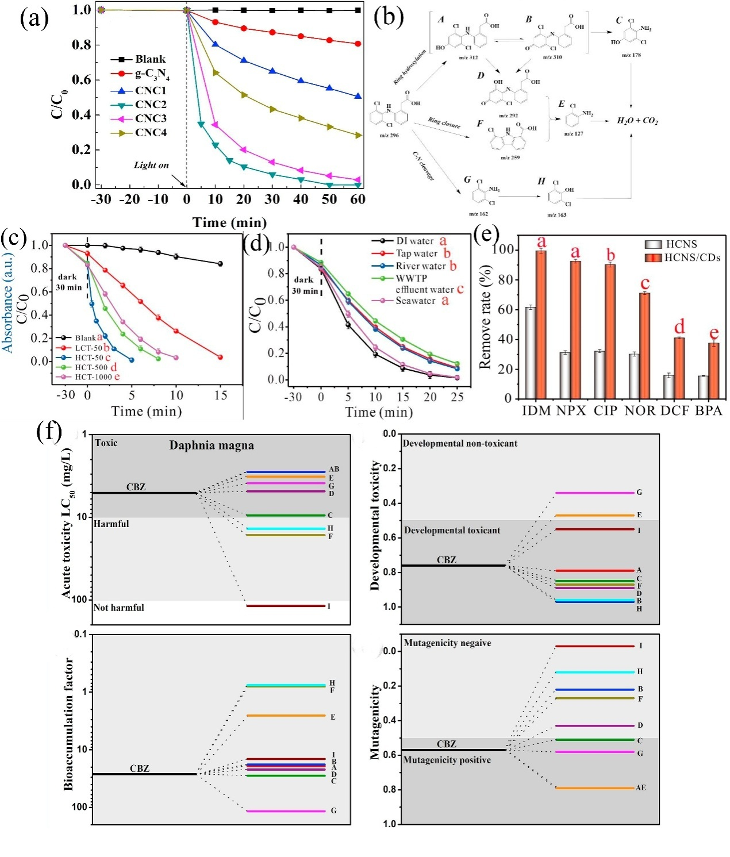

Fig. 8 Degradation kinetics (a) and degradation pathway (b) of DCF by various photocatalysts. Reorganized from ref 11 with permission from Elsevier, copyright 2019. (c) Photocatalytic activity of the HCNS/CDs based on the degradation of NPX; (d) Photodegradation of the NPX with the HCNS/CDs in different water matrices; (e) Photocatalytic degradation of PPCPs by HCNS and HCNS/CDs under visible light irradiation. Reorganized from ref 3 with permission from Elsevier, copyright 2020. (f) Toxicity assessment. Reorganized from ref 125 with permission from Elsevier, copyright 2020.

Additionally, CN-based materials were also used to remove many phenolic pollutants. Phenol-contaminated wastewater is high-toxicity industrial wastewater and is refractory to remove with a concentration range from 20 to 1200 mg/L 135. In a case of degrading phenol, a hierarchical PCN foam with nano-scale (∼50 nm) and micron-(1-2 μm) pores photocatalyst was synthesized. The reagents and products moved allodially in the inner pores to improve mass transfer progress, finally making 93.4% of phenol degrade within 180 min 136. Liu et al. synthesized 2D/2D Ti3C2/PCN Van der Waals (VDW) heterostructure photocatalyst to remove phenol 137. The photocatalytic ability of Ti3C2/PCN was available from day to night. The phenol removal efficiency obtained 98% over Ti3C2/PCN in the day-photocatalytic work (Fig. 9e) due to the enhanced absorbing visible light of PCN nanolayers and the build-in electric field of the VDW heterojunction. Besides, 32% of phenol was decomposed in the dark condition (Fig. 9f) due to the presence of Ti3C2, which could store supernumerary photo-induced electrons within visible light illumination and abandon them when exposed to electron acceptors. Furthermore, the Ti3C2/PCN exhibited the universal applicability and could degrade various organic contaminants. Gao et al. fabricated oxygen-doped graphitic carbon nitride (O-CN) with long-term stability for PMS activation toward the Bisphenol A degradation 138. The electronic structure was modulated to benefit the production of 1O2, contributing to the highly selective reactivity of the O-CN/PMS system. And the properties of PCN applied to organics removal are presented in Table 2. The research of organics removal is rich, comprehensive, and instructive. In the further, we should take more efforts to apply these technologies for practical sewage treatment.

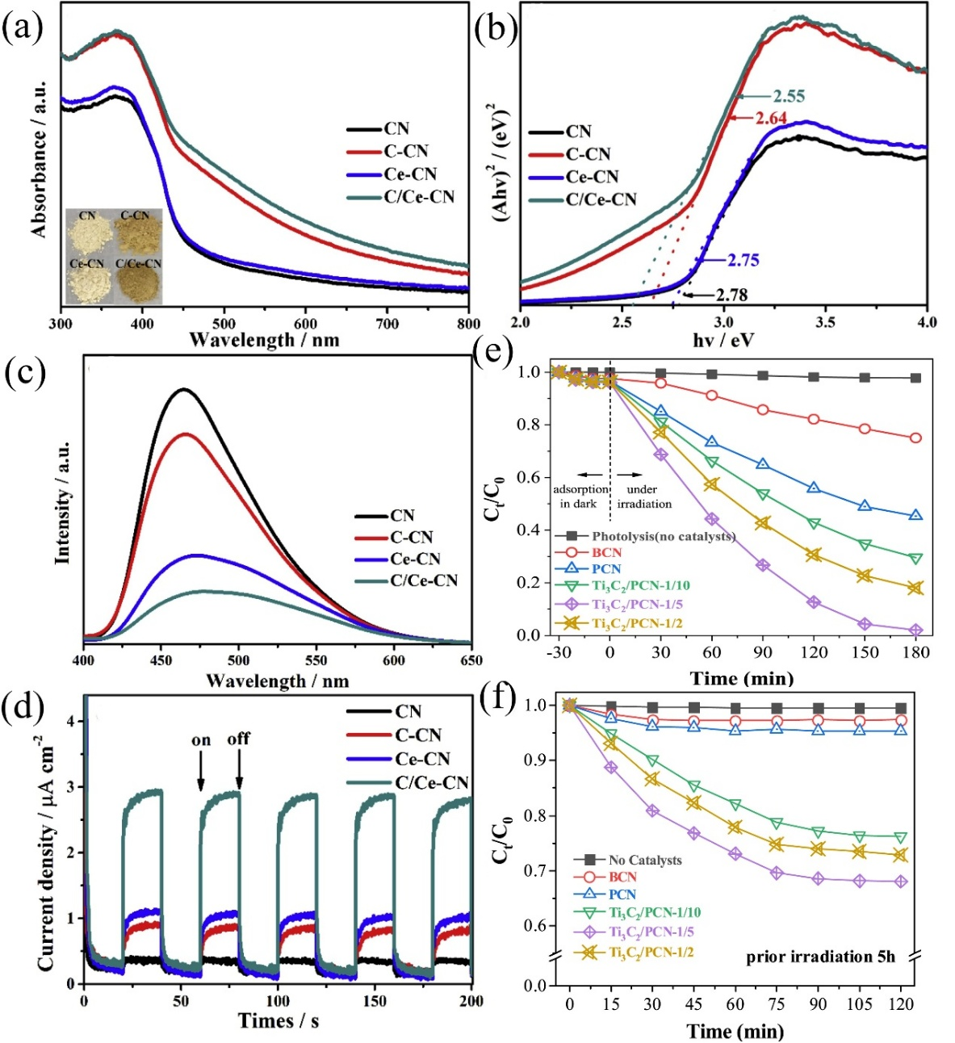

Fig. 9 (a) UV-DRS (the photograph of the samples were inserted); (b) Energy gap; (c) Photoluminescence emission spectra; (d) Transient photocurrents response of CN and modified CN. Reorganized from ref 133 with permission from Elsevier, copyright 2020. (e) Day-photocatalytic degradation; (f) Night-photocatalytic degradation of phenol. Reorganized from ref 137 with permission from Elsevier, copyright 2020.

Table 2 Performance summary of PCN catalysts for organics removal.

|  |  |  |  |  |  |  |
| --- | --- | --- | --- | --- | --- | --- |
| Organics | Concentration | Catalysis | Characters | Methods | Degradation rate | Ref |
| Diclofenac (DCF) | μg/L or ng/L | CQDs/PCN | Hybridizing strategy | photocatalysis | 0.074 min−1 96.1%/60min | 11 |
| Naproxen (NPX) | 0.1 ng/L to 7.69 μg/L | HCNS/CDs | Hybridizing strategy | photocatalysis | 0.1603 min−1 98.6%/25min | 3 |
| Carbamazepine (CBZ) | ng/L to μg/L | NiCo2O4/g-C3N4 | Hybridizing strategy | PMS/photocatalysis | 0.3956 min−1 99.0%/10 min | 125 |
| Sulfamethoxazole (SMX) | ng/L to μg/L | pNS g-C3N4 | Morphology control | photocatalysis | 0.085 min−1 93.39%/30min | 127 |
| S-C3N4/C-dot | Doping engineering | photocatalysis | 90%/180min | 139 |
| Indometacin (IDM) | 5−792 ng/L | COCN | Doping engineering | photocatalysis | 0.0391 min−1 | 128 |
| Tetracycline (TC) | hundreds μg/L | CNx | Defect engineering | PS/photocatalysis | 0.3475 min−1 | 140 |
| Ag/PCN | Hybridizing strategy | photocatalysis | 0.0120 min−1 83%/120min | 141 |
| NDCN-S | Doping engineering | photocatalysis | 81.72%/60min | 142 |
| C/Ce-CN | Doping engineering | photocatalysis | 0.04027 min−1 90.1%/60min | 133 |
| Tetracycline hydrochloride (TCH) | ng/L | Fe-POM/CNNS-Nvac | Doping/Defect engineering | Fenton-like | 0.1520 min−1 95.5%/18min | 104 |
| Oxytetracycline (OTC) | ng/L | Co/pCN | Anchoring single atom | photocatalysis | 0.038 min−1 75.7%/40min | 92 |
| Oxytetracycline hydrochloride (OTC-HCl) | ng/L | BNQDs/UPCN | Hybridizing strategy | photocatalysis | 0.0309 min−1 82%/60min | 134 |
| Phenol | 20 to 1200 mg/L | hierarchical PCN | Morphology control | photocatalysis | 93.4%/180min | 136 |
| Ti3C2/PCN | Hybridizing strategy | photocatalysis | 0.022 min−1 98%/180min | 137 |
| Bisphenol A (BPA) | 30 to 412 ng/L | O-CN | Doping engineering | PMS activation | 100%/45min | 138 |

## 3.3 Leachate control

Leachate, caused by the ultimate treatment of abundant industrial and municipal solids, consisted of heavy metals, ammonia-nitrogen compounds, refractory and toxic organic compounds 143, 144. Once high-concentration leachates are released to nature without strict treatment, it will pose hazard to the surface and subsurface water and even threaten human health 145. Therefore, it is vital to carefully treat liquid leachates before being released into the surroundings. AOPs, with high reactivity and low environmental risk, have been considered as potential and efficient methods for leachate treatment 146-148. There are various RS induced by AOPs, such as •OH, O2•-, SO4•- and 1O2, which can efficiently degraded organic chemicals 149. Since TiO2 combined with AOPs has been proved an efficient method to treat leachate 150, exploring alternative semiconductor photocatalysts to treat leachate has been a hot research spot. Considering the high photosensitivity and proper electronic structure of PCN, it is possible to substitute TiO2 and become a rising catalyst in leachate control. However, the application of PCN in AOPs is rare, and we do our best to review the existing research. Hu et al. demonstrated a method via immobilizing P. chrysosporium with g-C3N4 photocatalyst to degrade organics in landfill leachate 151. The obvious mesoporous sheet structure of g-C3N4 was beneficial for the carrier transfer and photocatalysis reaction. TOC removal was improved via the photocatalytic process of g-C3N4 as well as the biosorption and biodegradation process of P. chrysosporium. Besides, according to the Fig. 10, almost all organics in landfill leachate, particularly the long-chain hydrocarbons and volatile fatty acids, could be eliminated by immobilized *P. chrysosporium* under illumination. Therefore, immobilizing *P. chrysosporium* with g-C3N4 catalyst shows the potential for the landfill leachate treatment. In addition, it is vital to improve the nitrate reduction in leachate. The intimately coupling photocatalysis and biodegradation (ICPB) proposed by Zhang et al. not only can degrade bio-recalcitrant pollutants but also led to nitrate reduction 152. After 16 h, nitrate removal rate was up to 40.3% due to the synergy of the effect of in-situ cultivated biofilms and photocatalysis over TiO2/g-C3N4. Firstly, nitrate was reduced to nitrite under the effect of biofilms. Then the production of N2 improved because nitrite was further reduced with synergy of photocatalysts and biofilms. Therefore, an efficient method was proposed for the nitrate reduction. However, considering the complex ingredient of leachate in the practical conditions, the PCN as a remediator in leachate treatment still needs development, and the relevant reported studies is fragmented. But the mechanisms of PCN to eliminate the contaminants in leachate are adequate. Thus, combining AOPs with PCN shows the potential for refractory pollutants treatment in leachate.

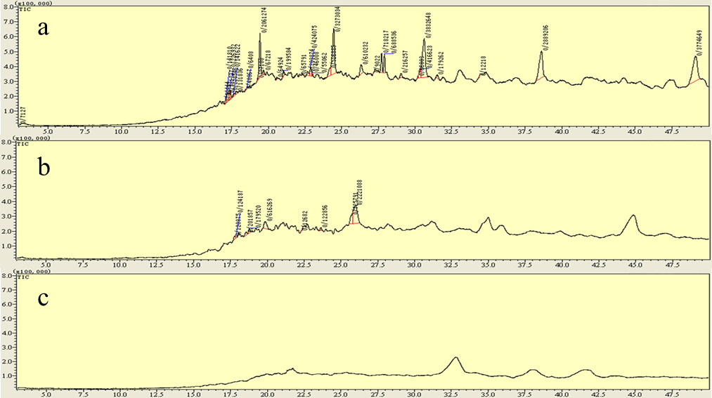

Fig. 10 The treatment of landfill leachate by immobilized P. chrysosporium: (a) original, (b) treated for 36 h, (c) treated for 72 h. Reorganized from ref 151 with permission from Elsevier, copyright 2017.

## 3.4 Constructing membrane system

In the actual wastewater treatment, it is a challenge to recycle catalyst, which may cause the high cost and second pollution. Membrane separation has been known as an effective method without secondary pollution for wastewater purification, where the membrane is must competent for contaminants separation and photocatalysts immobilization 153. Up to now, there are many efforts to immobilize catalysts on the membrane to construct hybrid system, and this system has been used in many aspects including heavy metal ions removal, organics removal 154, 155 and even disinfection progress 156. Gao et al. proposed a 3D electrical double-layer (EDL) ion transport membrane with highly interpenetrated porous structure consisting of core-shell g-C3N4@ multi-walled carbon nanotubes (MWCNTs) 157. The membrane provided some fast ionic transfer channels and modulated positive and negative charge density by external electric field, which was designed to realize the continuous separation of Zn2+. CNTs/MCU-C3N4/GO composite was immobilized on polyelectrolytes improved porous PVDF membrane support by the means of layer-by-layer self-assembly fabrication, resulting in visible light-responsive photocatalytic membranes 158. The composites exhibited wonderful water permeability (14.35 L m-2 h-1 bar-1), excellent RhB degradation (98.31%) and TC hydrochloride removal efficiency (84.81%). Meanwhile, the composites also showed excellent stability under ultrasonic operation and long-term testing, which exhibited potential in practical water treatment. However, the research on PCN is still in the infancy and more research is needed to explore the application in actual water.

## 3.5 Water disinfection and microbial control

Except for common organic contaminant in wastewater, many microbial contaminations in drinking water, which can cause pathogenic risks to humans, have also obtained great concern around the world, especially in countryside 159. People living in rural and remote areas usually use untreated surface water and have little access to improve drinking water sources, suffering a high risk of infections with pathogenic microorganisms. Therefore, it is crucial to control microorganism 160. Heterogeneous photocatalysis, which could generate electron-hole pairs and highly RS via semiconductor activating, is possible to make pathogen inactivation 161, 162 by damaging essential macromolecules and has been anticipated to next-generation sustainable method to purify water. More specifically, photocatalysis based g-C3N4 is considered as efficient and green technology for water disinfection due to its low cytotoxicity 26, antibacterial 27 and antiviral 28 activity. FPCN has been used as bactericides to inactivate *Escherichia coli (E. coli)* 163, 164,*Staphylococcus aureus (S. aureus)* 165, *Bacillus anthracis (B. anthracis)* 166, and*Salmonella* 167. For example, Zhu’s group synthesized a porous g-C3N4 nanosheet (PCNS) composite by the means of a simple two-step template-free strategy 164. PCNS possessed abundant surface-active sites to enhance charge transfer, therefore, *E. coli* cells were completely inactivated over PCNS within 240 min while the removal rate of *E. coli* were only obtained 77.1% by BCN (Fig. 11a). Fig. 11b-g further demonstrated the removal of *E. coli* by images and TEM analysis.

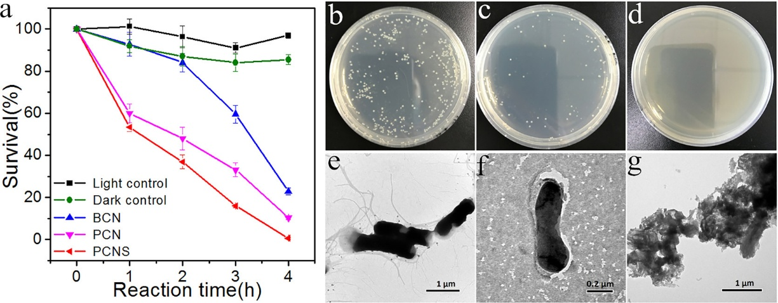

Fig. 11 (a) The disinfection activity of *E. coli* with a serious CN; (b) Images of *E. coli* colonies before irradiation; (c) after 2 h disinfection; (d) after 4 h disinfection with PCNS; (e) TEM images of *E. coli* before illumination and (f) after 2 h inactivation; (g) after 4 h disinfection using PCNS. Reorganized from ref 164 with permission from American Chemical Society, copyright 2017.

Kang et al. demonstrated a facile bacterial liquid exfoliation approach to exfoliate BCN into thin slice via using active bacteria (Fig. 12a) 168. According to morphology analysis, the surface area of bacteria-treated 2D g-C3N4 (BT-CN-2d) composites was amplified to 82.61 m2 g-1 with in-plane porous structure (Fig. 12b-d). Fig. 12e showed that the *E. coli* were completely killed within 120 min over BT-CN-2d, and Fig. 12f showed that ROS in low concentration was insufficient to cause bacterial damage. Chen et al. prepared 3D porous silver/silver bromide/g-C3N4@nitrogen-doped graphene aerogel (Ag/AgBr/g-C3N4@NGA) composite 165. Fig. 13a showed that the antibacterial property over Ag/AgBr/g-C3N4@NGA on *E. coli* and *S. aureus* were better than that of g-C3N4@NGA. The boosted antibacterial efficiency was ascribed to the formation of Z-scheme heterojunction between g-C3N4 and AgBr. After several recycle, the catalysis also exhibited excellent antibacterial efficiency (Fig. 13b). However, thicker cell wall composed peptidoglycan layers of *S. aureus*, a gram-positive bacterium, was less sensitive to Ag/AgBr/g-C3N4@NGA 165, 169. Therefore, the inactivation efficiency of *S. aureus* was below that of *E. coli* under the similar conditions. An oxidized PCN loaded with Ag nanoparticles (Ag/PCNO) was used to inactivate *S. aureus* 170. Because of the SPR and synergistic effects, 99.4% of *S. aureus* cells were killed with Ag-2/PCNO after 3 h of irradiation (Fig. 13c). Scanning electron microscope (SEM) analysis (Fig. 13d) proved that *S. aureus* cells were embedded into Ag-2/PCNO and became malformed even appearing some big cavities on the cell surfaces, indicating the inactivation e of *S. aureus*. The urea-derived g-C3N4 (u-g-C3N4) with in-plane pores had been used to fabricate photoactive, antimicrobial films to improve the antimicrobial activity 166. The inactivation efficiency against the *S. aureus*, methicillin-resistant *S. aureus* and *E. coli* O157:H7 improved approximately 10-fold compared to their previous work 171. Additionally, u-g-C3N4 had also been demonstrated to deactivate *B. anthracis* endospores. Wang et al. proposed vanadate quantum dots-interspersed g-C3N4 (vanadate QDs/g-C3N4) with chiffon-like ripples and wrinkles porous structure 167. The inactivation of *Salmonella* over AgVO3 QDs/g-C3N4 reached up to 96.4% within 10 min under visible-light illumination, while g-C3N4 showed only 54.13% bactericidal efficiency in the same condition.

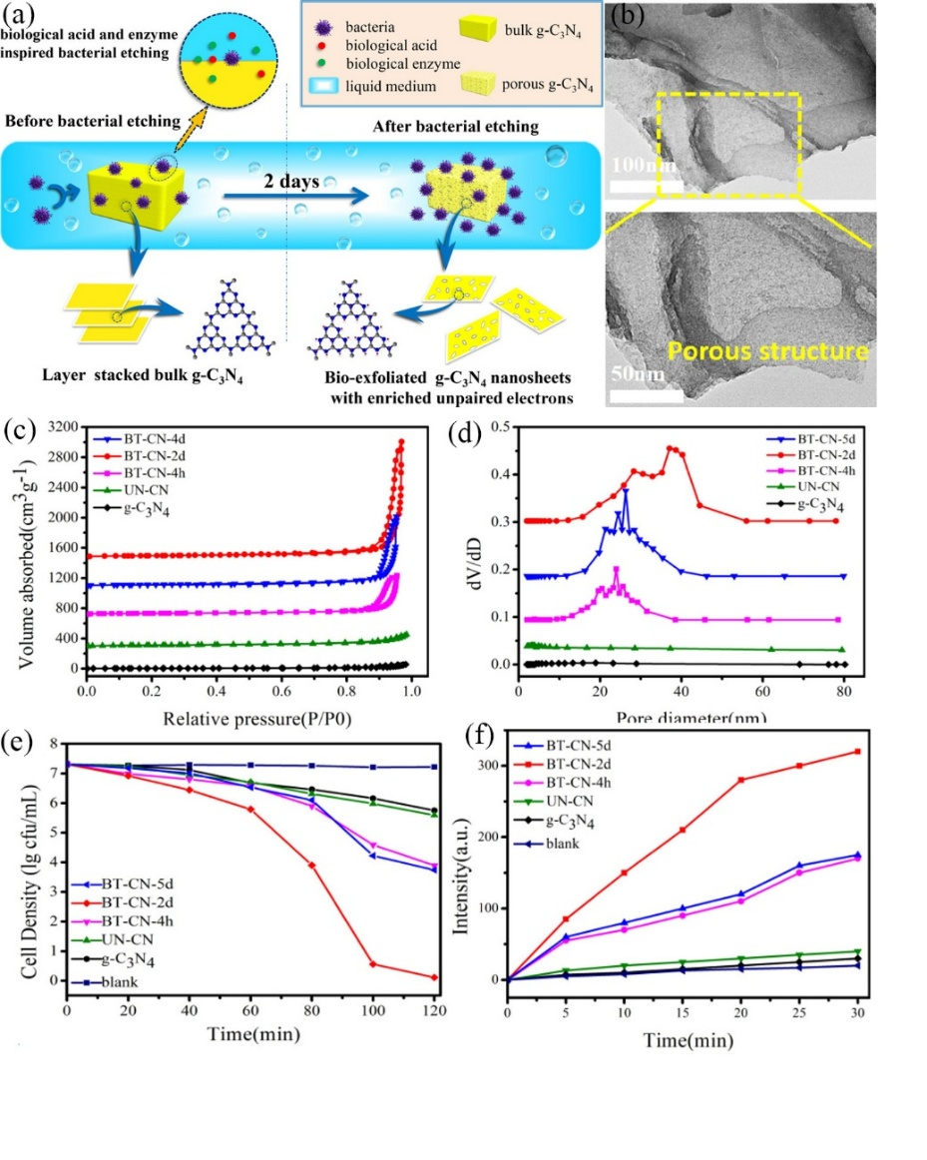

Fig. 12 (a) Possible bacterial-inspired preparation and mechanism with BT-CN; (b) TEM images of BT-CN-2d; (c) N2 adsorption–desorption isotherms; (d) the pore size distribution; (e) *E. coli* photocatalytic inactivation efficiency in saturated bacterial fluid; (f) ROS generation amount in hypoxic water with BT-CN samples. Reorganized from ref 168 with permission from American Chemical Society, copyright 2018.

Besides, g-C3N4-based materials are also used as viricides and algaecides. The illness risk of viral pathogens is higher than that of bacterial pathogens, therefore, it is serious to inactivate viruses. The size and structure of bacteriophage *MS2* is similar to many human pathogenic enteric viruses including easy propagation, and non-pathogenicity to humans 28, 172, so it has been selected as the model virus for study. Zhang et al. developed a sustainable water-surface-floating composites by integrating g-C3N4 and expanded perlite (g-C3N4/EP) 172. The high specific surface area could optimize performance for *MS2* disinfection, which achieved 8-log inactivation of *MS2* within 4 h visible-light irradiation without stirring (Fig. 13e). Importantly, in real water source, g-C3N4/EP-520 showed excellent *MS2* inactivation, demonstrating its high-efficiency for water disinfection (Fig. 13f). Besides, microalgae such as *cyanobacteria* can cause a threat to drinking water because of its potential to cause algal blooms and release toxic metabolites in eutrophic lakes. It was reported that g-C3N4/TiO2 floating photocatalyst could remove *Microcystis aeruginosa* (*M. aeruginosa*) and *Microcystin-LR* within visible light irradiation. During the degradation of *M. aeruginosa*, *Microcystin-LR* was released into the water. g-C3N4/TiO2 not only removed *M. aeruginosa* but also made *Microcystin-LR* undetectable 173. Z-scheme g-C3N4-MoO3 (Mo-CN) photocatalysts with mesoporous structure had been proved to be beneficial for the surface adsorption for algal cells. In addition, h+ and •OH radicals made around 97% algal cells inactivate within 3 h visible light irradiation 174. Composite expanded perlite (i.e., EP/Al2O3) deposited by g-C3N4 could also make *M. aeruginosa* inactivate, and in situ remediation driven by visible light showed the potential for cyano-harmful algal blooms (HABs) control in aquatic systems 175. Xu et al. proposed high active BiVO4/g-C3N4 nanosheets heterojunction photocatalysts to remove *microcystin-LR* (MC-LR) 176. Large surface area and plenty mesopores of g-C3N4 provided excellent contact area for BiVO4. The MC-LR (5 mg/L) was obviously eliminated within 10 minutes. The synergy of abundant mesoporous structure and the interface Z-scheme heterojunction accelerated the photo-induced electron-hole separation and then benefited the removal of MC-LR. And the properties of PCN applied to eliminate bacteria, virus and algae are presented in Table 3.

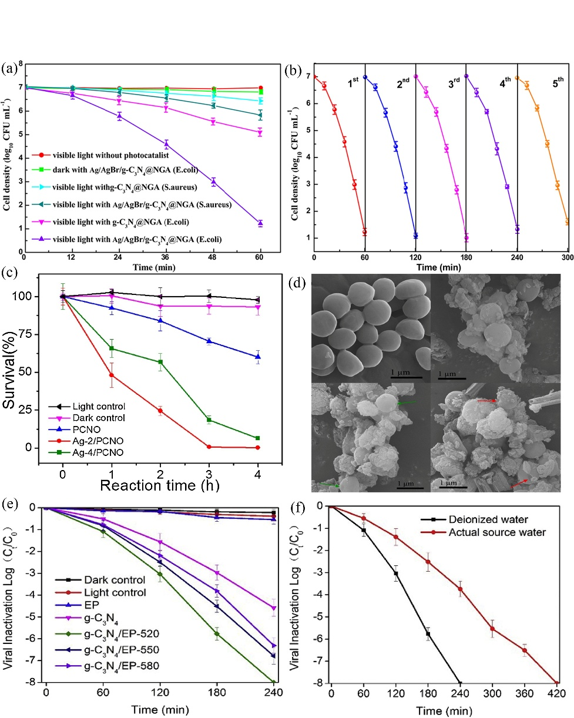

Fig. 13 (a) Disinfection performance on *E. coli* and *S. aureus* over different catalysis; (b) Cycle test of Ag/AgBr/g-C3N4@NGA on *E. coli* under visible light for five continuous operation. Reorganized from ref 165 with permission from Elsevier, copyright 2019. (c) Photocatalytic disinfection activity for *S. aureus* with PCNO and Ag/PCNO; (d) SEM images of *S. aureus* cells after different time treatment. Reorganized from ref 170 with permission from Elsevier, copyright 2019. (e) Photocatalytic *MS2* inactivation; (f) The effect of water matrix on viral inactivation with g-C3N4/EP-520. Reorganized from ref 172 with permission from Elsevier, copyright 2018.

Table 3 Performance summary of PCN catalysts for water disinfection and microbial control.

|  |  |  |  |  |  |  |
| --- | --- | --- | --- | --- | --- | --- |
| Catalyst | Target microorganism | Catalyst dose (g/L) | Microbial level | Reaction time (min) | Inactivation performance | Ref |
| PCNS | *E. coli* | 0.4 | 5×106 CFU mL-1 | 240 | completely inactivation | 164 |
| PCNS | *E. coil K-12* | 0.4 | 6.5×106 CFU mL-1 | 120 | 6.5 log  inactivation | 177 |
| Ag/AgBr/g-C3N4@NGA | *E. coli* | 0.268 | 1×107 CFU mL-1 | 60 | 6 log inactivation | 165 |
| *S. aureus* | 0.268 | 1×107 CFU mL-1 | 60 | 1.2 log inactivation |
| VN-PCN | *E. coli* | 4 | 1×106 CFU mL-1 | 120 | 4.8log inactivation | 178 |
| *S. aureus* | 4 | 1×106 CFU mL-1 | 120 | 4.24log inactivation |
| Ag/mpg-CN | *E. coli* | 0.1 | 1×106 CFU mL-1 | 180 | 80% inactivation | 179 |
| Fe3O4/Pd/mpg-C3N4 | *E. coli* | 0.1 | 1×108 CFU mL-1 | 120 | 99.9% inactivation | 180 |
| *S. aureus* | 0.1 | 1×108 CFU mL-1 | 120 | 99.8% inactivation |
| Ag/PCNO | *S. aureus* | 0.2 | 1×107 CFU mL-1 | 180 | 99.4% inactivation | 170 |
| AgVO3/g-C3N4 | *Salmonella* | 0.75 | 1×107 CFU mL-1 | 10 | 7log inactivation | 167 |
| g-C3N4/EP | *E. coli* | 0.6 | 1×108 CFU mL-1 | 180 | 8log inactivation | 172 |
| *MS2* | 0.6 | 1×108 CFU mL-1 | 240 | 8log inactivation |
| g-C3N4 | *MS2* | 0.15 | 1×108 PFU mL-1 | 360 | completely inactivation | 28 |
| g-C3N4/TiO2 | *M. aeruginosa* | 2 | 2.7×106 cells/mL | 360 | 88.1% | 173 |
| *Microcystin-LR* | 2 | 50 μg/L | 360 | 54.4% |
| Mo-CN | *M. aeruginosa* | 0.15 | 2.7×106 cells/mL | 360 | 97% | 174 |
| floating g-C3N4 | *M. aeruginosa* | 2 | 2.7×106 cells/mL | 360 | 74.4% | 175 |
| BiVO4/g-C3N4 | *Microcystin-LR* | 0.5 | 5 mg/L | 10 | 100% | 181 |
| Ag2O/g-C3N4 | *M. aeruginosa* | 0.05 | 4.78×106 cells/mL | 360 | 99.94 % | 182 |

In this section, the applications of PCN materials in the removal of bacteria, virus, and algae have been reviewed. Because PCN can generate highly RS via visible light activating, it is anticipated to be efficient for water disinfection and microbial control. However, the researches mainly concentrated on the inactivation of bacteria, especially for *E. coli* and *S. aureus*. The study for other bacteria, virus, and alage inactivation is still in its infancy. Besides, there are little studies for water disinfection and microbial control via other AOPs besides photocatalysis, which can also achieve water disinfection in theory. Therefore, there are plenty aspects for water disinfection with PCN needing to explore.

# 4. Conclusions and Prospects

PCN, with large surface area, strong electron transport ability, low cytotoxicity, has been an excellent catalyst for water treatment. On account of modifying PCN, the morphology and electronic structure have been adjusted to provide more reaction sites and suppress the charge carrier recombination. For example, ultrathin nanosheets can shorten charge migration distances and accelerate carriers transfer compared with bulk structure. The existence of defects on the surface can trap photo-induced electrons and prevent the rapid recombination of photo-carriers. In addition, the carbon vacancies can enhance visible light absorption. Doping heteroatom can extend the absorption edge and inhibit the electron-hole recombination. Nonmetallic atom may replace the sites of C or N, which alter the atomic arrangement and molecular orbital distribution benefiting separation of photo-induced carriers and extending the absorption edge. Metal atoms are easy captured into in-planar cave of g-C3N4 due to the strong interactions between nitrogen pots and metal cations. Doping metal can narrow the energy gap, accelerate the charge mobility and alter the morphology. Hybridizing strategy has been proved to the efficient method to transfer charge carrier and suppress their recombination. Anchoring single atom can achieve maximum atom-utilization efficiency and improve stability to enhance catalytic performance. These modifications make PCN shown extensive potential in wastewater treatment. The paper firstly reviews the primary application in wastewater treatment over FPCN, such as the adsorption and degradation for heavy metal iron, dye, and other organics. These applications provide fundamental guidance for other study. In addition, the control for landfill leachate with FPCN has also been reviewed, providing the potential for complex ingredient removal in actual water bodies. Furthermore, in order to realize catalyst recycling and reduce the possible influence for environment, constructing membrane with PCN has been discussed to treat pollutants. Last but not least, FPCN applied in water disinfection microbial control has been concluded, which is closely related to our drinking water safety.

Although many efforts have been taken to make PCN with excellent catalytic performance, there are still some challenges with PCN from preparation to application. Notably, it is also need to take many efforts to design and optimize PCN meeting practical application. The specific statements have been summarized as follow:

1. Highly ordered mesopores and specific structure of PCN can generate abundant active sites comprise of low-coordinated atoms in defect sites, but the related green synthesis method is still in its infancy. Especially, doping heteroatoms may affect the morphology of PCN to further enhance the catalytic performance. Therefore, it is also taken many efforts to research multiple modification strategy.

2. The research of theoretical calculation is the trend of future development. Theoretical calculation can explain the electronic band structures and reaction mechanism via molecular simulations and reaction kinetics, which can provide guide for catalyst design and modification. The theoretical calculation about PCN is still at the infancy stage and full of challenge.

3. In particular, most of the current researches about PCN focus on adsorption and photocatalysis/photoelectrocatalysis due to the large surface area and excellent photoelectric property. However, the research of PCN applied to other AOPs is rare and need more deep exploration. Especially, some new systems, such as single-atom catalysts, have been proposed recently and are needed further development.

4. The other applications, like leachate control and constructing membrane system, are in their infancy. The control of leachate is related to our life and efficient technologies is imperative. Constructing membrane system is convenient for the sample recycle and couple with other physical or biological technology to achieve more degradation. And it is necessary to further explore the relevant application.

5. In water disinfection and microbial control, researches mainly concentrated on the photo-inactivation of bacteria, especially for *E. coli* and *S. aureus*. The study for other bacteria, virus and alage inactivation needs further development. Besides, on previous report, photocatalysis based PCN is used to degrade bacteria. However, we speculated whether the combination of photocatalyst and bacteria can also remove pollutants, which offer a new insight for further research.

6. It is also needed to analysis the possible impact on the environment. Although PCN is low cytotoxicity, the poisoning of hybridized PCN catalysts still deserves more attention. Besides, toxicity analysis of intermediates in degradation process is also worth discussing to avoid potential risk.

In conclusion, the review summarizes the development of PCN from modification to application. The study proposes the insight for the design and application of PCN in new field. We hope the review will put the guide for the design of desired catalysts in the future.

# Declaration of interests

The authors declare that they have no known competing financial interests or personal relationships that could have appeared to influence the work reported in this paper.

# Acknowledgements

This study was financially supported by the Program for the National Natural Science Foundation of China (U20A20323, 51521006, 51879101, 51579098, 51779090, 51909084), the National Program for Support of Top-Notch Young Professionals of China (2014), the Program for Changjiang Scholars and Innovative Research Team in University (IRT-13R17), Hunan Natural Science Foundation (2020JJ3009), Hunan Researcher Award Program (2020RC3025), the Fundamental Research Funds for the Central Universities (531119200086, 531118010114, 541109060031, 531118040083), the Hunan Provincial Innovation Foundation for Postgraduate (CX20190260) and the Three Gorges Follow-up Research Project (2017HXXY-05).

# References

1. H. Wang, H. Wang, Z. Wang, L. Tang, G. Zeng, P. Xu, M. Chen, T. Xiong, C. Zhou, X. Li, D. Huang, Y. Zhu, Z. Wang and J. Tang, *Chemical Society Reviews*, 2020, **49**, 4135-4165.

2. Y. Yang, X. Li, C. Zhou, W. Xiong, G. Zeng, D. Huang, C. Zhang, W. Wang, B. Song, X. Tang, X. Li and H. Guo, *Water Research*, 2020, **184**, 116200.

3. Y. Wu, F. Wang, X. Jin, X. Zheng, Y. Wang, D. Wei, Q. Zhang, Y. Feng, Z. Xie, P. Chen, H. Liu and G. Liu, *Water Research*, 2020, **172**, 115492.

4. J. He, C. Lai, L. Qin, B. Li, S. Liu, L. Jiao, Y. Fu, D. Huang, L. Li, M. Zhang, X. Liu, H. Yi, L. Chen and Z. Li, *Chemosphere*, 2020, **256**, 127083.

5. H. Wang, X. Yuan, H. Wang, X. Chen, Z. Wu, L. Jiang, W. Xiong and G. Zeng, *Applied Catalysis B: Environmental*, 2016, **193**, 36-46.

6. J. Jin, S. Li, X. Peng, W. Liu, C. Zhang, Y. Yang, L. Han, Z. Du, K. Sun and X. Wang, *Bioresource Technology*, 2018, **256**, 247-253.

7. M. Liu, D. Zhang, J. Han, C. Liu, Y. Ding, Z. Wang and A. Wang, *Chemical Engineering Journal*, 2020, **382**, 123017.

8. Y. Yu, W. Xu, J. Fang, D. Chen, T. Pan, W. Feng, Y. Liang and Z. Fang, *Applied Catalysis B: Environmental*, 2020, **268**, 118751.

9. S. Yang, Q. Li, L. Chen, Z. Chen, B. Hu, H. Wang and X. Wang, *Chemical Engineering Journal*, 2020, **385**, 123909.

10. H. Yi, M. Yan, D. Huang, G. Zeng, C. Lai, M. Li, X. Huo, L. Qin, S. Liu, X. Liu, B. Li, H. Wang, M. Shen, Y. Fu and X. Guo, *Applied Catalysis B: Environmental*, 2019, **250**, 52-62.

11. W. Liu, Y. Li, F. Liu, W. Jiang, D. Zhang and J. Liang, *Water Research*, 2019, **151**, 8-19.

12. R. A. Rather and I. M. C. Lo, *Water Research*, 2020, **168**, 115166.

13. L. Li, C. Lai, F. Huang, M. Cheng, G. Zeng, D. Huang, B. Li, S. Liu, M. Zhang, L. Qin, M. Li, J. He, Y. Zhang and L. Chen, *Water Res*, 2019, **160**, 238-248.

14. Z. Wang, C. Lai, L. Qin, Y. Fu, J. He, D. Huang, B. Li, M. Zhang, S. Liu, L. Li, W. Zhang, H. Yi, X. Liu and X. Zhou, *Chem. Eng. J.*, 2020, **392**, 124851.

15. X. Zhou, Z. Zeng, G. Zeng, C. Lai, R. Xiao, S. Liu, D. Huang, L. Qin, X. Liu, B. Li, H. Yi, Y. Fu, L. Li, M. Zhang and Z. Wang, *Chemical Engineering Journal*, 2020, **401**, 126127.

16. S. Liu, C. Lai, B. Li, C. Zhang, M. Zhang, D. Huang, L. Qin, H. Yi, X. Liu, F. Huang, X. Zhou and L. Chen, *Chemical Engineering Journal*, 2020, **384**.

17. K. R. Reddy, C. V. Reddy, M. N. Nadagouda, N. P. Shetti, S. Jaesool and T. M. Aminabhavi, *Journal of Environmental Management*, 2019, **238**, 25-40.

18. X. Liu, D. Huang, C. Lai, L. Qin, G. Zeng, P. Xu, B. Li, H. Yi and M. Zhang, *Small*, 2019, **15**, 1900133.

19. C. Zhou, C. Lai, P. Xu, G. Zeng, D. Huang, Z. Li, C. Zhang, M. Cheng, L. Hu, J. Wan, F. Chen, W. Xiong and R. Deng, *ACS Sustainable Chemistry & Engineering*, 2018, **6**, 6941-6949.

20. Y. Yang, Z. T. Zeng, G. M. Zeng, D. L. Huang, R. Xiao, C. Zhang, C. Y. Zhou, W. P. Xiong, W. J. Wang, M. Cheng, W. J. Xue, H. Guo, X. Tang and D. H. He, *Applied Catalysis B-Environmental*, 2019, **258**, 11.

21. W. Xing, G. Chen, C. Li, Z. Han, Y. Hu and Q. Meng, *Nanoscale*, 2018, **10**, 5239-5245.

22. J. Cai, J. Huang, S. Wang, J. Iocozzia, Z. Sun, J. Sun, Y. Yang, Y. Lai and Z. Lin, *Advanced Materials*, 2019, **31**, 1806314.

23. C. Zhou, Z. Zeng, G. Zeng, D. Huang, R. Xiao, M. Cheng, C. Zhang, W. Xiong, C. Lai, Y. Yang, W. Wang, H. Yi and B. Li, *J Hazard Mater*, 2019, **380**, 120815-120815.

24. J. Xu, Y. Wang and Y. Zhu, *Langmuir*, 2013, **29**, 10566-10572.

25. Y. Gu, M. Ye, Y. Wang, H. Li, H. Zhang, G. Wang, Y. Zhang and H. Zhao, *Journal of Materials Chemistry A*, 2020, **8**, 12687-12698.

26. L.-S. Lin, Z.-X. Cong, J. Li, K.-M. Ke, S.-S. Guo, H.-H. Yang and G.-N. Chen, *Journal of Materials Chemistry B*, 2014, **2**, 1031-1037.

27. J. Huang, W. Ho and X. Wang, *Chemical Communications*, 2014, **50**, 4338-4340.

28. Y. Li, C. Zhang, D. Shuai, S. Naraginti, D. Wang and W. Zhang, *Water Research*, 2016, **106**, 249-258.

29. S. Sun and S. Liang, *Nanoscale*, 2017, **9**, 10544-10578.

30. D. Tang, Y. Chen, M. Yin, Q. Yang, Y. Zhou and L. Zhou, *Materials Science in Semiconductor Processing*, 2020, **105**, 104735.

31. Y. Yang, G. M. Zeng, D. L. Huang, C. Zhang, D. H. He, C. Y. Zhou, W. J. Wang, W. P. Xiong, X. P. Li, B. S. Li, W. Y. Dong and Y. Zhou, *Applied Catalysis B-Environmental*, 2020, **272**, 14.

32. M. W. Kadi, R. M. Mohamed, A. A. Ismail and D. W. Bahnemann, *Journal of Colloid and Interface Science*, 2020, **580**, 223-233.

33. V. K. Tomer, R. Malik, V. Chaudhary, Y. K. Mishra, L. Kienle, R. Ahuja and L. Lin, *Applied Materials Today*, 2019, **16**, 193-203.

34. C. Zhang, Y. Liu, X. Li, H. Chen, T. Wen, Z. Jiang, Y. Ai, Y. Sun, T. Hayat and X. Wang, *Chemical Engineering Journal*, 2018, **346**, 406-415.

35. H. Ashrafi, M. Akhond and G. Absalan, *Journal of Photochemistry and Photobiology A: Chemistry*, 2020, **396**, 112533.

36. F. Guo, M. Li, H. Ren, X. Huang, K. Shu, W. Shi and C. Lu, *Separation and Purification Technology*, 2019, **228**, 115770.

37. Y. Yang, H. Zhao, H. Yang, P. Qiu, B. Zhou and N. Zhang, *Journal of Environmental Chemical Engineering*, 2018, **6**, 890-897.

38. H.-J. Li, B.-W. Sun, L. Sui, D.-J. Qian and M. Chen, *Physical Chemistry Chemical Physics*, 2015, **17**, 3309-3315.

39. X. She, L. Liu, H. Ji, Z. Mo, Y. Li, L. Huang, D. Du, H. Xu and H. Li, *Applied Catalysis B: Environmental*, 2016, **187**, 144-153.

40. J. Wang, B. Gao, M. Dou, X. Huang and Z. Ma, *Environmental Research*, 2020, **184**, 109339.

41. S. Zhang, Y. Liu, P. Gu, R. Ma, T. Wen, G. Zhao, L. Li, Y. Ai, C. Hu and X. Wang, *Applied Catalysis B: Environmental*, 2019, **248**, 1-10.

42. J. Wen, J. Xie, X. Chen and X. Li, *Applied Surface Science*, 2017, **391**, 72-123.

43. Y. Yang, J. Chen, Z. Mao, N. An, D. Wang and B. D. Fahlman, *RSC Advances*, 2017, **7**, 2333-2341.

44. S. Zhang, H. Gao, Y. Huang, X. Wang, T. Hayat, J. Li, X. Xu and X. Wang, *Environmental Science: Nano*, 2018, **5**, 1179-1190.

45. L. Wang, Y. Hong, E. Liu, X. Duan, X. Lin and J. Shi, *Carbon*, 2020, **163**, 234-243.

46. J. Wan, C. Pu, R. Wang, E. Liu, X. Du, X. Bai, J. Fan and X. Hu, *International Journal of Hydrogen Energy*, 2018, **43**, 7007-7019.

47. P. Li, L. Liu, W. An, H. Wang, H. Guo, Y. Liang and W. Cui, *Applied Catalysis B: Environmental*, 2020, **266**, 118618.

48. J. Li, B. Shen, Z. Hong, B. Lin, B. Gao and Y. Chen, *Chemical Communications*, 2012, **48**, 12017-12019.

49. X. Chen, R. Shi, Q. Chen, Z. Zhang, W. Jiang, Y. Zhu and T. Zhang, *Nano Energy*, 2019, **59**, 644-650.

50. L. Zhou, J. Feng, B. Qiu, Y. Zhou, J. Lei, M. Xing, L. Wang, Y. Zhou, Y. Liu and J. Zhang, *Applied Catalysis B: Environmental*, 2020, **267**, 118396.

51. M. Shalom, M. Guttentag, C. Fettkenhauer, S. Inal, D. Neher, A. Llobet and M. Antonietti, *Chemistry of Materials*, 2014, **26**, 5812-5818.

52. Q. Liu, X. Wang, Q. Yang, Z. Zhang and X. Fang, *Applied Surface Science*, 2018, **450**, 46-56.

53. D. Ruan, S. Kim, M. Fujitsuka and T. Majima, *Applied Catalysis B: Environmental*, 2018, **238**, 638-646.

54. Y. Jiang, Z. Sun, C. Tang, Y. Zhou, L. Zeng and L. Huang, *Applied Catalysis B: Environmental*, 2019, **240**, 30-38.

55. P. Niu, M. Qiao, Y. Li, L. Huang and T. Zhai, *Nano Energy*, 2018, **44**, 73-81.

56. Q. Liang, Z. Li, Z.-H. Huang, F. Kang and Q.-H. Yang, *Advanced Functional Materials*, 2015, **25**, 6885-6892.

57. L. Jing, D. Wang, Y. Xu, M. Xie, J. Yan, M. He, Z. Song, H. Xu and H. Li, *Journal of Colloid and Interface Science*, 2020, **566**, 171-182.

58. L. Jiang, X. Yuan, Y. Pan, J. Liang, G. Zeng, Z. Wu and H. Wang, *Applied Catalysis B: Environmental*, 2017, **217**, 388-406.

59. L. Zhou, H. Zhang, H. Sun, S. Liu, M. O. Tade, S. Wang and W. Jin, *Catalysis Science & Technology*, 2016, **6**, 7002-7023.

60. G. Liao, Y. Gong, L. Zhang, H. Gao, G.-J. Yang and B. Fang, *Energy & Environmental Science*, 2019, **12**, 2080-2147.

61. X. Liu, R. Ma, L. Zhuang, B. Hu, J. Chen, X. Liu and X. Wang, *Critical Reviews in Environmental Science and Technology*, 2020, DOI: 10.1080/10643389.2020.1734433, 1-40.

62. X. Guo, L. Rao, P. Wang, L. Zhang and Y. Wang, *Int J Environ Res Public Health*, 2019, **16**.

63. G. Dong, K. Zhao and L. Zhang, *Chemical Communications*, 2012, **48**, 6178-6180.

64. N. Bao, X. Hu, Q. Zhang, X. Miao, X. Jie and S. Zhou, *Applied Surface Science*, 2017, **403**, 682-690.

65. X. Ma, Y. Lv, J. Xu, Y. Liu, R. Zhang and Y. Zhu, *The Journal of Physical Chemistry C*, 2012, **116**, 23485-23493.

66. S. Cao, B. Fan, Y. Feng, H. Chen, F. Jiang and X. Wang, *Chemical Engineering Journal*, 2018, **353**, 147-156.

67. H. Yu, L. Shang, T. Bian, R. Shi, G. I. N. Waterhouse, Y. Zhao, C. Zhou, L.-Z. Wu, C.-H. Tung and T. Zhang, *Advanced Materials*, 2016, **28**, 5080-5086.

68. C. Hu, M.-S. Wang, C.-H. Chen, Y.-R. Chen, P.-H. Huang and K.-L. Tung, *Journal of Membrane Science*, 2019, **580**, 1-11.

69. S. Zhao, Y. Zhang, Y. Wang, Y. Zhou, K. Qiu, C. Zhang, J. Fang and X. Sheng, *Journal of Power Sources*, 2017, **370**, 106-113.

70. Z.-A. Lan, G. Zhang and X. Wang, *Applied Catalysis B: Environmental*, 2016, **192**, 116-125.

71. Y. Yang, H. Jin, C. Zhang, H. Gan, F. Yi and H. Wang, *Journal of Alloys and Compounds*, 2020, **821**, 153439.

72. Y. Gao, F. Hou, S. Hu, B. Wu and B. Jiang, *Applied Surface Science*, 2019, **481**, 1089-1095.

73. J. Barrio, A. Grafmüller, J. Tzadikov and M. Shalom, *Applied Catalysis B: Environmental*, 2018, **237**, 681-688.

74. J. Jiang, S. Cao, C. Hu and C. Chen, *Chinese Journal of Catalysis*, 2017, **38**, 1981-1989.

75. W. Miao, Y. Liu, X. Chen, Y. Zhao and S. Mao, *Carbon*, 2020, **159**, 461-470.

76. W. Wu, Z. Ruan, J. Li, Y. Li, Y. Jiang, X. Xu, D. Li, Y. Yuan and K. Lin, *Nano-Micro Letters*, 2019, **11**, 10.

77. J.-C. Wang, C.-X. Cui, Y. Li, L. Liu, Y.-P. Zhang and W. Shi, *Journal of Hazardous Materials*, 2017, **339**, 43-53.

78. J. Lin, W. Tian, H. Zhang, X. Duan, H. Sun and S. Wang, *Energy & Fuels*, 2021, **35**, 7-24.

79. J. Low, J. Yu, M. Jaroniec, S. Wageh and A. A. Al-Ghamdi, *Advanced Materials*, 2017, **29**, 1601694.

80. S. Wu, H.-J. Zhao, C.-F. Li, J. Liu, W. Dong, H. Zhao, C. Wang, Y. Liu, Z.-Y. Hu, L. Chen, Y. Li and B.-L. Su, *Journal of Colloid and Interface Science*, 2019, **538**, 99-107.

81. Z. Dong, J. Pan, B. Wang, Z. Jiang, C. Zhao, J. Wang, C. Song, Y. Zheng, C. Cui and C. Li, *Journal of Alloys and Compounds*, 2018, **747**, 788-795.

82. J. Lv, K. Dai, J. Zhang, Q. Liu, C. Liang and G. Zhu, *Separation and Purification Technology*, 2017, **178**, 6-17.

83. A. Meng, L. Zhang, B. Cheng and J. Yu, *Advanced Materials*, 2019, **31**, 1807660.

84. H. Zhang, W. Tian, X. Duan, H. Sun, Y. Shen, G. Shao and S. Wang, *Nanoscale*, 2020, **12**, 6937-6952.

85. H. Zhang, W. Tian, L. Zhou, H. Sun, M. Tade and S. Wang, *Applied Catalysis B: Environmental*, 2018, **223**, 2-9.

86. W. Chen, M. Liu, S. Wei, X. Li, L. Mao and W. Shangguan, *Journal of Alloys and Compounds*, 2020, **836**, 155401.

87. J. Xu, X. Zheng, Z. Feng, Z. Lu, Z. Zhang, W. Huang, Y. Li, D. Vuckovic, Y. Li, S. Dai, G. Chen, K. Wang, H. Wang, J. K. Chen, W. Mitch and Y. Cui, *Nature Sustainability*, 2021, **4**, 233-241.

88. Y. Chen, S. Ji, C. Chen, Q. Peng, D. Wang and Y. Li, *Joule*, 2018, **2**, 1242-1264.

89. H. Zhang, W. Tian, X. Duan, H. Sun, S. Liu and S. Wang, *Advanced Materials*, 2020, **32**, 1904037.

90. S. Wang, J. Li, Q. Li, X. Bai and J. Wang, *Nanoscale*, 2020, **12**, 364-371.

91. X. Li, S. Zhao, X. Duan, H. Zhang, S.-z. Yang, P. Zhang, S. P. Jiang, S. Liu, H. Sun and S. Wang, *Applied Catalysis B: Environmental*, 2021, **283**, 119660.

92. Y. Yang, G. Zeng, D. Huang, C. Zhang, D. He, C. Zhou, W. Wang, W. Xiong, B. Song, H. Yi, S. Ye and X. Ren, *Small*, 2020, **16**, 2001634.

93. W. Zhao, J. Wang, R. Yin, B. Li, X. Huang, L. Zhao and L. Qian, *Journal of Colloid and Interface Science*, 2020, **564**, 28-36.

94. S. Ye, M. Yan, X. Tan, J. Liang, G. Zeng, H. Wu, B. Song, C. Zhou, Y. Yang and H. Wang, *Applied Catalysis B: Environmental*, 2019, **250**, 78-88.

95. Y. Sheng, Z. Wei, H. Miao, W. Yao, H. Li and Y. Zhu, *Chemical Engineering Journal*, 2019, **370**, 287-294.

96. M. Ramalingam, V. K. Ponnusamy and S. N. Sangilimuthu, *Microchimica Acta*, 2019, **186**, 69.

97. Y. Wu, H. Pang, Y. Liu, X. Wang, S. Yu, D. Fu, J. Chen and X. Wang, *Environmental Pollution*, 2019, **246**, 608-620.

98. B. Ou, J. Wang, Y. Wu, S. Zhao and Z. Wang, *Chemical Engineering Journal*, 2020, **380**, 122600.

99. M. Li, B. Wang, M. Yang, Q. Li, D. G. Calatayud, S. Zhang, H. Wang, L. Wang and B. Mao, *Separation and Purification Technology*, 2020, **239**, 116515.

100. X. Zhao, D. Pan, X. Chen, R. Li, T. Jiang, W. Wang, G. Li and D. Y. C. Leung, *Applied Surface Science*, 2019, **467-468**, 658-665.

101. J. Safaei, H. Ullah, N. A. Mohamed, M. F. Mohamad Noh, M. F. Soh, A. A. Tahir, N. Ahmad Ludin, M. A. Ibrahim, W. N. R. Wan Isahak and M. A. Mat Teridi, *Applied Catalysis B: Environmental*, 2018, **234**, 296-310.

102. Q. Song, J. Li, L. Wang, Y. Qin, L. Pang and H. Liu, *Journal of Catalysis*, 2019, **370**, 176-185.

103. J. Hu, C. Chen, T. Hu, J. Li, H. Lu, Y. Zheng, X. Yang, C. Guo and C. M. Li, *Journal of Materials Chemistry A*, 2020, **8**, 19484-19492.

104. J. Jiang, X. Wang, Y. Liu, Y. Ma, T. Li, Y. Lin, T. Xie and S. Dong, *Applied Catalysis B: Environmental*, 2020, **278**, 119349.

105. C. Liu, L. Liu, X. Tian, Y. Wang, R. Li, Y. Zhang, Z. Song, B. Xu, W. Chu, F. Qi and A. Ikhlaq, *Applied Catalysis B: Environmental*, 2019, **255**, 117763.

106. W. Feng, J. Fang, G. Zhou, L. Zhang, S. Lu, S. Wu, Y. Chen, Y. Ling and Z. Fang, *Molecular Catalysis*, 2017, **434**, 69-79.

107. X. Du, X. Yi, P. Wang, J. Deng and C.-c. Wang, *Chinese Journal of Catalysis*, 2019, **40**, 70-79.

108. H. Wang, Q. Li, S. Zhang, Z. Chen, W. Wang, G. Zhao, L. Zhuang, B. Hu and X. Wang, *Catalysis Today*, 2019, **335**, 110-116.

109. L. Qin, Z. Zeng, G. Zeng, C. Lai, A. Duan, R. Xiao, D. Huang, Y. Fu, H. Yi, B. Li, X. Liu, S. Liu, M. Zhang and D. Jiang, *Applied Catalysis B: Environmental*, 2019, **259**, 118035.

110. L. Qin, D. Huang, P. Xu, G. Zeng, C. Lai, Y. Fu, H. Yi, B. Li, C. Zhang, M. Cheng, C. Zhou and X. Wen, *Journal of Colloid and Interface Science*, 2019, **534**, 357-369.

111. Z. Hu, J. Zhou, Y. Ai, L. Liu, L. Qi, R. Jiang, H. Bao, J. Wang, J. Hu, H.-b. Sun and Q. Liang, *J. Catal.*, 2018, **368**, 20-30.

112. V. Balakumar, H. Kim, J. W. Ryu, R. Manivannan and Y.-A. Son, *Journal of Materials Science & Technology*, 2020, **40**, 176-184.

113. Y. Fu, L. Qin, D. Huang, G. Zeng, C. Lai, B. Li, J. He, H. Yi, M. Zhang, M. Cheng and X. Wen, *Applied Catalysis B-Environmental*, 2019, **255**.

114. J. Zhang and Z. Ma, *Chinese Journal of Chemical Engineering*, 2018, **26**, 753-760.

115. J.-Y. Zhang, S.-H. Zhang, J. Li, X.-C. Zheng and X.-X. Guan, *Journal of Molecular Liquids*, 2020, **310**, 113242.

116. D. P. Dutta and D. Dagar, *Journal of Nanoscience and Nanotechnology*, 2020, **20**, 2179-2194.

117. J. Di, J. Xia, X. Li, M. Ji, H. Xu, Z. Chen and H. Li, *Carbon*, 2016, **107**, 1-10.

118. H. Shen, M. Li, W. Guo, G. Li and C. Xu, *Applied Surface Science*, 2020, **507**, 145086.

119. Z. Wang, H. Wang, Z. Zeng, G. Zeng, P. Xu, R. Xiao, D. Huang, X. Chen, L. He, C. Zhou, Y. Yang, Z. Wang, W. Wang and W. Xiong, *Applied Catalysis B: Environmental*, 2020, **267**, 118700.

120. F. Wang, P. Chen, Y. Feng, Z. Xie, Y. Liu, Y. Su, Q. Zhang, Y. Wang, K. Yao, W. Lv and G. Liu, *Applied Catalysis B: Environmental*, 2017, **207**, 103-113.

121. S. Li, W. Shi, W. Liu, H. Li, W. Zhang, J. Hu, Y. Ke, W. Sun and J. Ni, *Science of The Total Environment*, 2018, **615**, 906-917.

122. L. Lonappan, S. K. Brar, R. K. Das, M. Verma and R. Y. Surampalli, *Environment International*, 2016, **96**, 127-138.

123. S. Luo, L. Gao, Z. Wei, R. Spinney, D. D. Dionysiou, W.-P. Hu, L. Chai and R. Xiao, *Water Research*, 2018, **137**, 233-241.

124. L. Sbardella, I. Velo-Gala, J. Comas, I. Rodríguez-Roda Layret, A. Fenu and W. Gernjak, *Journal of Hazardous Materials*, 2019, **380**, 120869.

125. J. Jiang, X. Wang, C. Zhang, T. Li, Y. Lin, T. Xie and S. Dong, *Chemical Engineering Journal*, 2020, **397**, 125356.

126. L. Zhang, F. Sun, D. Wu, W. Yan and Y. Zhou, *Water Research*, 2020, **185**, 116156.

127. G. Liu, Z. Zhang, M. Lv, H. Wang, D. Chen and Y. Feng, *Separation and Purification Technology*, 2020, **235**, 116172.

128. X. Zheng, Q. Zhang, T. Chen, Y. Wu, J. Hao, C. Tan, P. Chen, F. Wang, H. Liu, W. Lv and G. Liu, *Journal of Hazardous Materials*, 2020, **386**, 121961.

129. X. Huo, Y. Yang, Q. Niu, Y. Zhu, G. Zeng, C. Lai, H. Yi, M. Li, Z. An, D. Huang, Y. Fu, B. Li, L. Li and M. Zhang, *Chemical Engineering Journal*, 2021, **403**.

130. W. Wang, Q. Niu, G. Zeng, C. Zhang, D. Huang, B. Shao, C. Zhou, Y. Yang, Y. Liu, H. Guo, W. Xiong, L. Lei, S. Liu, H. Yi, S. Chen and X. Tang, *Applied Catalysis B: Environmental*, 2020, **273**, 119051.

131. S. Ye, G. Zeng, X. Tan, H. Wu, J. Liang, B. Song, N. Tang, P. Zhang, Y. Yang, Q. Chen and X. Li, *Applied Catalysis B-Environmental*, 2020, **269**.

132. C.-H. Han, H.-D. Park, S.-B. Kim, V. Yargeau, J.-W. Choi, S.-H. Lee and J.-A. Park, *Water Research*, 2020, **172**, 115514.

133. K. Wu, D. Chen, S. Lu, J. Fang, X. Zhu, F. Yang, T. Pan and Z. Fang, *Journal of Hazardous Materials*, 2020, **382**, 121027.

134. Y. Yang, C. Zhang, D. Huang, G. Zeng, J. Huang, C. Lai, C. Zhou, W. Wang, H. Guo, W. Xue, R. Deng, M. Cheng and W. Xiong, *Applied Catalysis B: Environmental*, 2019, **245**, 87-99.

135. L. Zhao, D. Xiao, Y. Liu, H. Xu, H. Nan, D. Li, Y. Kan and X. Cao, *Water Research*, 2020, **172**, 115494.

136. Y. Li, Z. Ruan, Y. He, J. Li, K. Li, Y. Jiang, X. Xu, Y. Yuan and K. Lin, *Applied Catalysis B: Environmental*, 2018, **236**, 64-75.

137. N. Liu, N. Lu, H. Yu, S. Chen and X. Quan, *Chemosphere*, 2020, **246**, 125760.

138. Y. Gao, Y. Zhu, L. Lyu, Q. Zeng, X. Xing and C. Hu, *Environmental Science & Technology*, 2018, **52**, 14371-14380.

139. S. Xu, Y. Zhao, X. Sun, X. Zheng, S. Ni, Q. Yue and B. Gao, *Catalysis Today*, 2019, **335**, 502-510.

140. H. Sun, F. Guo, J. Pan, W. Huang, K. Wang and W. Shi, *Chemical Engineering Journal*, 2021, **406**, 126844.

141. W. Xu, S. Lai, S. C. Pillai, W. Chu, Y. Hu, X. Jiang, M. Fu, X. Wu, F. Li and H. Wang, *Journal of Colloid and Interface Science*, 2020, **574**, 110-121.

142. L. Jiang, X. Yuan, G. Zeng, J. Liang, Z. Wu, H. Yu, D. Mo, H. Wang, Z. Xiao and C. Zhou, *Journal of Colloid and Interface Science*, 2019, **536**, 17-29.

143. F. C. Moreira, J. Soler, A. Fonseca, I. Saraiva, R. A. R. Boaventura, E. Brillas and V. J. P. Vilar, *Water Research*, 2015, **81**, 375-387.

144. D. Ma, H. Yi, C. Lai, X. Liu, X. Huo, Z. An, L. Li, Y. Fu, B. Li, M. Zhang, L. Qin, S. Liu and L. Yang, *Chemosphere*, 2021, **275**, 130104.

145. H. Wang, Z. Cheng, H. Yuan, N. Zhu, Z. Lou and P. Otieno, *Science of The Total Environment*, 2020, **710**, 136287.

146. J. N. Göde, D. Hoefling Souza, V. Trevisan and E. Skoronski, *Journal of Environmental Chemical Engineering*, 2019, **7**, 103352.

147. K. Roy and V. S. Moholkar, *Chemical Engineering Journal*, 2020, **386**, 121294.

148. M. Anjum, R. Kumar and M. A. Barakat, *Journal of Environmental Management*, 2018, **212**, 65-76.

149. P. Gautam, S. Kumar and S. Lokhandwala, *Journal of Cleaner Production*, 2019, **237**, 117639.

150. D. E. Meeroff, F. Bloetscher, D. V. Reddy, F. Gasnier, S. Jain, A. McBarnette and H. Hamaguchi, *Journal of Hazardous Materials*, 2012, **209-210**, 299-307.

151. L. Hu, Y. Liu, G. Zeng, G. Chen, J. Wan, Y. Zeng, L. Wang, H. Wu, P. Xu, C. Zhang, M. Cheng and T. Hu, *Chemosphere*, 2017, **184**, 1071-1079.

152. H. Zhang, Z. Liu, Y. Li, C. Zhang, Y. Wang, W. Zhang, L. Wang, L. Niu, P. Wang and C. Wang, *Applied Surface Science*, 2020, **503**, 144092.

153. Y. Shi, J. Huang, G. Zeng, W. Cheng and J. Hu, *Journal of Membrane Science*, 2019, **584**, 364-392.

154. K. G. Zhou, D. McManus, E. Prestat, X. Zhong, Y. Y. Shin, H. L. Zhang, S. J. Haigh and C. Casiraghi, *Journal of Materials Chemistry A*, 2016, **4**, 11666-11671.

155. Y. Jiang, P. Biswas and J. D. Fortner, *Environmental Science: Water Research & Technology*, 2016, **2**, 915-922.

156. R.-Y. C. Zi-Ya LIU, Man-Ying ZHANG, *Journal of Inorganic Materials*, 2019, **34**, 478-486.

157. F. Gao, X. Du, X. Hao, X. Ma, L. Chang, N. Han, G. Guan and K. Tang, *Chemical Engineering Journal*, 2020, **380**, 122413.

158. Y. Shi, D. Wan, J. Huang, Y. Liu and J. Li, *Chemosphere*, 2020, **252**, 126581.

159. L. Chen, W. Xiang, H. Wu, S. Ouyang, B. Zhou, Y. Zeng, Y. Chen and Y. Kuzyakov, *Soil Biology and Biochemistry*, 2019, **130**, 113-121.

160. W. Wang, C. Zhou, Y. Yang, G. Zeng, C. Zhang, Y. Zhou, J. Yang, D. Huang, H. Wang, W. Xiong, X. Li, Y. Fu, Z. Wang, Q. He, M. Jia and H. Luo, *Chemical Engineering Journal*, 2021, **404**, 126540.

161. D. Wang, S. C. Pillai, S. H. Ho, J. Zeng, Y. Li and D. D. Dionysiou, *Applied Catalysis B: Environmental*, 2018, **237**, 721-741.

162. D. Wang, B. Zhu, X. He, Z. Zhu, G. Hutchins, P. Xu and W.-N. Wang, *Environmental Science: Nano*, 2018, **5**, 1096-1106.

163. W. Wang, Z. Zeng, G. Zeng, C. Zhang, R. Xiao, C. Zhou, W. Xiong, Y. Yang, L. Lei, Y. Liu, D. Huang, M. Cheng, Y. Yang, Y. Fu, H. Luo and Y. Zhou, *Chemical Engineering Journal*, 2019, **378**, 122132.

164. J. Xu, Z. Wang and Y. Zhu, *ACS Applied Materials & Interfaces*, 2017, **9**, 27727-27735.

165. Y. Chen, P. Wang, Y. Liang, M. Zhao, Y. Jiang, G. Wang, P. Zou, J. Zeng, Y. Zhang and Y. Wang, *Journal of Colloid and Interface Science*, 2019, **536**, 389-398.

166. J. H. Thurston, N. M. Hunter, L. J. Wayment and K. A. Cornell, *Journal of Colloid and Interface Science*, 2017, **505**, 910-918.

167. R. Wang, X. Kong, W. Zhang, W. Zhu, L. Huang, J. Wang, X. Zhang, X. Liu, N. Hu, Y. Suo and J. Wang, *Applied Catalysis B: Environmental*, 2018, **225**, 228-237.

168. S. Kang, W. Huang, L. Zhang, M. He, S. Xu, D. Sun and X. Jiang, *ACS Applied Materials & Interfaces*, 2018, **10**, 13796-13804.

169. O. K. Dalrymple, E. Stefanakos, M. A. Trotz and D. Y. Goswami, *Applied Catalysis B: Environmental*, 2010, **98**, 27-38.

170. J. Xu, Q. Gao, X. Bai, Z. Wang and Y. Zhu, *Catalysis Today*, 2019, **332**, 227-235.

171. J. H. Thurston, N. M. Hunter and K. A. Cornell, *RSC Advances*, 2016, **6**, 42240-42248.

172. C. Zhang, Y. Li, D. Shuai, W. Zhang, L. Niu, L. Wang and H. Zhang, *Chemosphere*, 2018, **208**, 84-92.

173. J. Song, X. Wang, J. Ma, X. Wang, J. Wang, S. Xia and J. Zhao, *Chemical Engineering Journal*, 2018, **348**, 380-388.

174. D. Wang, Y. Ao and P. Wang, *Science of The Total Environment*, 2020, **746**, 141149.

175. J. Song, X. Wang, J. Ma, X. Wang, J. Wang and J. Zhao, *Applied Catalysis B: Environmental*, 2018, **226**, 83-92.

176. Y. Xu, B. Hu, J. Liu, K. Tao, R. Wang, Y. Ren, X. Zhao, J. Xu and X. Song, *Journal of the American Ceramic Society*, 2019, **103**, 1281-1292.

177. N. He, S. Cao, L. Zhang, Z. Tian, H. Chen and F. Jiang, *Chemosphere*, 2019, **235**, 1116-1124.

178. H. Liu, S. Ma, L. Shao, H. Liu, Q. Gao, B. Li, H. Fu, S. Fu, H. Ye, F. Zhao and J. Zhou, *Applied Catalysis B: Environmental*, 2020, **261**, 118201.

179. P. Yadav, S. T. Nishanthi, B. Purohit, A. Shanavas and K. Kailasam, *Carbon*, 2019, **152**, 587-597.

180. D. Thakur, Q. T. H. Ta and J. S. Noh, *Molecules*, 2019, **24**.

181. Y. Xu, B. Hu, J. Liu, K. Tao, R. Wang, Y. Ren, X. Zhao, J. Xu and X. Song, *Journal of the American Ceramic Society*, 2020, **103**, 1281-1292.

182. G. Fan, B. Du, J. Zhou, W. Yu, Z. Chen and S. Yang, *Applied Catalysis B: Environmental*, 2020, **265**, 118610.

1. *Corresponding author at: College of Environmental Science and Engineering, Hunan University, Changsha, Hunan 410082, China (G.M. Zeng and C. Lai).

   Tel.: +86–731– 88822754; fax: +86–731–88823701.

   E-mail address: zgming@hnu.edu.cn (G.M. Zeng), laicui@hnu.edu.cn (C. Lai).

   1 These authors contribute equally to this article